A
Major Project Report
on
Exploring Deep Learning & ML Approaches for Brain Hemorrhage Detection
submitted in partial fulfillment of the requirement for the award of the degree of
BACHELOR OF ENGINEERING
In
COMPUTER SCIENCE & ENGINEERING
By
Muhammad Aasim Uz Zaman | 160922733020
Syed Altamash Uddin Siddiqui | 160922733032
Nawaz Khan | 160922733037
Faiz Ur Rahman | 160922733049

Under the esteemed guidance of
Name of the Guide
Designation & Dept. of CSE

Department of Computer Science & Engineering
LORDS INSTITUTE OF ENGINEERING AND TECHNOLOGY
(UGC Autonomous)
Approved by AICTE | Affiliated to Osmania University | Estd.2003
Sy.No.32, Himayat Sagar, Near TGPA Junction, Hyderabad-500091, India.
(2026)
 | LORDS INSTITUTE OF ENGINEERING & TECHNOLOGY  (UGC Autonomous)  Approved by AICTE | Affiliated to Osmania University | Estd.2003.  Accredited with ‘A’ grade by NAAC | Accredited by NBA  Department of Computer Science & Engineering

CERTIFICATE
This is to certify that the project report entitled “Exploring Deep Learning & ML Approaches for Brain Hemorrhage Detection” being Submitted by Muhammad Aasim Uz Zaman (160922733020), Syed Altamash Uddin Siddiqui (160922733032), Nawaz Khan (160922733037), and Faiz Ur Rahman (160922733049) in partial fulfillment of the requirements for the award of the degree of Bachelor of Engineering in Computer Science and Engineering during the academic year 2024-2025.
This is further certified that the work done under my guidance, and the results of this work have not been submitted elsewhere for the award of any of the degree
Internal Guide | Head of the Department
Name of the Guide  Designation | Dr. TK Shaik Shavali  HOD - CSE

Principal | External Examiner
Dr. Ravi Kishore Singh | Date:

 | LORDS INSTITUTE OF ENGINEERING & TECHNOLOGY  (UGC Autonomous)  Approved by AICTE | Affiliated to Osmania University | Estd.2003.  Accredited with ‘A’ grade by NAAC | Accredited by NBA  Department of Computer Science & Engineering

DECLARATION BY THE CANDIDATE
We, hereby declare that the project report entitled “Exploring Deep Learning & ML Approaches for Brain Hemorrhage Detection”, under the guidance of Name of the Guide, Designation, Department of Computer Science and Engineering, Lords Institute of Engineering & Technology, affiliated to Osmania University, Hyderabad is submitted in partial fulfillment of the requirements for the award of the degree of Bachelor of Engineering in Computer Science and Engineering.
This is a record of bonafide work carried out by us and the results embodied in this project have not been reproduced or copied from any source. The results embodied in this project report have not been submitted to any other university or institute for the award of any other degree.
Muhammad Aasim Uz Zaman | 160922733020
Syed Altamash Uddin Siddiqui | 160922733032
Nawaz Khan | 160922733037
Faiz Ur Rahman | 160922733049

 | LORDS INSTITUTE OF ENGINEERING & TECHNOLOGY  (UGC Autonomous)  Approved by AICTE | Affiliated to Osmania University | Estd.2003.  Accredited with ‘A’ grade by NAAC | Accredited by NBA  Department of Computer Science & Engineering

ACKNOWLEDGMENT
First, we wish to thank GOD Almighty who created heavens and earth, who helped us in completing this project and we also thank our Parents who encouraged us in this period.
We would like to thank Name of the Guide, Designation, Dept. of CSE, Lords Institute of Engineering & Technology, affiliated to Osmania University, Hyderabad, our project internal guide, for her guidance and help. Her insight during the course of our major project and regular guidance were invaluable to us.
We would like to express our deep sense of gratitude to Dr. TK Shaik Shavali, Professor & Head of the Department, Computer Science & Engineering, Lords Institute of Engineering & Technology, affiliated to Osmania University, Hyderabad, for his encouragement and cooperation throughout the project.
We would also like to thank Dr. Ravi Kishore Singh, Principal of our college, for extending his help.
Muhammad Aasim Uz Zaman | 160922733020
Syed Altamash Uddin Siddiqui | 160922733032
Nawaz Khan | 160922733037
Faiz Ur Rahman | 160922733049
(Lords Institute of Engineering and Technology)

 | LORDS INSTITUTE OF ENGINEERING & TECHNOLOGY  (UGC Autonomous)  Approved by AICTE | Affiliated to Osmania University | Estd.2003.  Accredited with ‘A’ grade by NAAC | Accredited by NBA  Department of Computer Science & Engineering

Vision of the Institute:
Lords Institute of Engineering and Technology strives for excellence in professional education through quality, innovation and teamwork and aims to emerge as a premier institute in the state and across the nation.
Mission of the Institute:
- To impart quality professional education that meets the needs of present and emerging technological world.
- To strive for student achievement and success, preparing them for life, career and leadership.
- To provide a scholarly and vibrant learning environment that enables faculty, staff and students to achieve personal and professional growth.
- To contribute to advancement of knowledge, in both fundamental and applied areas of engineering and technology.
- To forge mutually beneficial relationships with government organizations, industries, society and the alumni.

 | LORDS INSTITUTE OF ENGINEERING & TECHNOLOGY  (UGC Autonomous)  Approved by AICTE | Affiliated to Osmania University | Estd.2003.  Accredited with ‘A’ grade by NAAC | Accredited by NBA  Department of Computer Science & Engineering

Vision of the Department:
To emerge as a center of excellence for quality Computer Science and Engineering education with innovation, leadership and values.
Mission of the Department:
- DM1: Provide fundamental and practical training through learner – centric Teaching-Learning Process and state-of-the-art infrastructure.
- DM2: Develop design, research, and entrepreneurial skills for successful career.
- DM3: Promote training and activities through Industry-Academia interactions.
Note: DM: Department Mission

 | LORDS INSTITUTE OF ENGINEERING & TECHNOLOGY  (UGC Autonomous)  Approved by AICTE | Affiliated to Osmania University | Estd.2003.  Accredited with ‘A’ grade by NAAC | Accredited by NBA  Department of Computer Science & Engineering

B.E. Computer Science and Engineering Program Educational Objectives (PEOs):
PEO1 | Exhibit strong foundations in Basic Sciences, Computer Science and allied engineering
PEO2 | Identify, formulate, analyze and create professional solutions, novel products using appropriate tools and techniques, design skills.
PEO3 | Pursue successful career with continuous learning, with emphasis on competency oriented towards industry
PEO4 | Practice ethics, managerial and leadership skills to work cohesively within a group

 | LORDS INSTITUTE OF ENGINEERING & TECHNOLOGY  (UGC Autonomous)  Approved by AICTE | Affiliated to Osmania University | Estd.2003.  Accredited with ‘A’ grade by NAAC | Accredited by NBA  Department of Computer Science & Engineering

B.E. Computer Science and Engineering Program Outcomes (POs):
Engineering Graduates will be able to:
S. No. | Program Outcomes (POs)
1. | PO1: Engineering Knowledge: Apply knowledge of mathematics, natural science, computing, engineering fundamentals and an engineering specialization as specified in WK1 to WK4 respectively to develop to the solution of complex engineering problems.
2. | PO2: Problem Analysis: Identify, formulate, review research literature and analyze complex engineering problems reaching substantiated conclusions with consideration for sustainable development. (WK1 to WK4)
3. | PO3: Design/Development of Solutions: Design creative solutions for complex engineering problems and design/develop systems/components/processes to meet identified needs with consideration for the public health and safety, whole-life cost, net zero carbon, culture, society and environment as required. (WK5)
4. | PO4: Conduct Investigations of Complex Problems: Conduct investigations of complex engineering problems using research-based knowledge including design of experiments, modelling, analysis & interpretation of data to provide valid conclusions. (WK8).
5. | PO5: Engineering Tool Usage: Create, select and apply appropriate techniques, resources and modern engineering & IT tools, including prediction and modelling recognizing their limitations to solve complex engineering problems. (WK2 and WK6)
6. | PO6: The Engineer and The World: Analyze and evaluate societal and environmental aspects while solving complex engineering problems for its impact on sustainability with reference to economy, health, safety, legal framework, culture and environment. (WK1, WK5, and WK7).
7. | PO7: Ethics: Apply ethical principles and commit to professional ethics, human values, diversity and inclusion; adhere to national & international laws. (WK9)
8. | PO8: Individual and Collaborative Team work: Function effectively as an individual, and as a member or leader in diverse/multi-disciplinary teams.
9. | PO9: Communication: Communicate effectively and inclusively within the engineering community and society at large, such as being able to comprehend and write effective reports and design documentation, make effective presentations considering cultural, language, and learning differences
10. | PO10: Project Management and Finance: Apply knowledge and understanding of engineering management principles and economic decision-making and apply these to one’s own work, as a member and leader in a team, and to manage projects and in multidisciplinary environments.
11. | PO11: Life-Long Learning: Recognize the need for, and have the preparation and ability for i) independent and life-long learning ii) adaptability to new and emerging technologies and iii) critical thinking in the broadest context of technological change. (WK8)

 | LORDS INSTITUTE OF ENGINEERING & TECHNOLOGY  (UGC Autonomous)  Approved by AICTE | Affiliated to Osmania University | Estd.2003.  Accredited with ‘A’ grade by NAAC | Accredited by NBA  Department of Computer Science & Engineering

B.E. Computer Science and Engineering Program Specific Outcomes (PSO’s):
PSO1 | Professional Skills: Implement computer programs in the areas related to algorithms, system software, multimedia, web design, big data analytics and networking for efficient analysis and design of computer-based systems of varying complexity
PSO2 | Problem-Solving Skills: Apply standard practices and strategies in software service management using open-ended programming environment with agility to deliver a quality service for business success

 | LORDS INSTITUTE OF ENGINEERING & TECHNOLOGY  (UGC Autonomous)  Approved by AICTE | Affiliated to Osmania University | Estd.2003.  Accredited with ‘A’ grade by NAAC | Accredited by NBA  Department of Computer Science & Engineering

Course Outcomes: C424 - Major Project
Student will be able to
CO. No | Description | Blooms  Taxonomy  Level
C424.1 | Demonstrate the ability to synthesize and apply the knowledge and skills acquired in the academic program to real-world problems. | BTL3
C424.2 | Evaluate different solutions based on economic and technical feasibility. | BTL5
C424.3 | Effectively plan a a project and confidently perform all aspects of project management | BTL4
C424.4 | Demonstrate effective oral communication skills | BTL2
C424.5 | Demonstrate effective team work and written skills | BTL1

 | LORDS INSTITUTE OF ENGINEERING & TECHNOLOGY  (UGC Autonomous)  Approved by AICTE | Affiliated to Osmania University | Estd.2003.  Accredited with ‘A’ grade by NAAC | Accredited by NBA  Department of Computer Science & Engineering

Course Articulation Matrix:
Mapping of Course Outcomes (CO) with Program Outcomes (PO) and Program Specific Outcomes (PSO’s):
Course  Outcome s  (CO) | PO1 | PO2 | PO3 | PO4 | PO5 | PO6 | PO7 | PO 8 | PO9 | PO10 | PO11 | PSO1 | PSO2
C424.1. | 3 | 3 | 3 | 1 | 3 | 2 | 1 | 1 | 2 | 2 | 3 | 3 | 3
C424.2. | 3 | 3 | 3 | 2 | 2 | 3 | 1 | 1 | 2 | 3 | 3 | 3 | 3
C424.3. | 3 | 3 | 3 | 3 | 3 | 2 | 1 | 1 | 3 | 2 | 3 | 3 | 3
C424.4. | 3 | 2 | 1 | 1 | 2 | 2 | 1 | 2 | 3 | 2 | 3 | 3 | 3
C424.5. | 3 | 1 | 2 | 1 | 2 | 2 | 1 | 2 | 3 | 2 | 3 | 3 | 3
Average | 3.0 | 2.4 | 2.4 | 1.6 | 2.4 | 2.2 | 1.0 | 1.4 | 2.6 | 2.2 | 3.0 | 3.0 | 3.0

Level:
1- Low correlation (Low), 2- Medium correlation (Medium), 3-High correlation (High)
SDG Mapping:
SDG | Mapped  Indicator | SDG | Mapped  Indicator | SDG | Mapped  Indicator
1 NO  POVERTY |  | 7 AFFORDABLE AND  CLEAN ENERGY |  | 13 CLIMATE  ACTION
2 ZERO  HUNGER |  | 8 DECENT WORK AND  ECONOMIC GROWTH |  | 14 LIFE  BELOW WATER
3 GOOD HEALTH  AND WELL-BEING | ✓ | 9 INDUSTRY, INNOVATION  AND INFRASTRUCTURE | ✓ | 15 LIFE  ON LAND
4 QUALITY  EDUCATION | ✓ | 10 REDUCED  INEQUALITIES |  | 16 PEACE, JUSTICE  AND STRONG INSTITUTIONS
5 GENDER  EQUALITY |  | 11 SUSTAINABLE CITIES  AND COMMUNITIES |  | 17 PARTNERSHIPS  FOR THE GOALS
6 CLEAN WATER  AND SANITATION |  | 12 RESPONSIBLE  CONSUMPTION AND PRODUCTION

ABSTRACT
Brain hemorrhage is a critical medical condition that requires immediate diagnosis and treatment. Computed Tomography (CT) scans are widely used for detecting brain hemorrhages, but manual interpretation by radiologists is time-consuming, subjective, and prone to human error, particularly under high workload conditions. The growing demand for faster and more accurate diagnostic tools has led to the exploration of artificial intelligence and deep learning techniques for automated medical image analysis.
This project presents a comprehensive web-based system for automated brain hemorrhage detection using a custom-built Convolutional Neural Network (CNN) architecture. The CNN model comprises four convolutional blocks with progressively increasing filter sizes (32, 64, 128, 256), each followed by ReLU activation and max-pooling layers, culminating in a fully connected classification head with dropout regularization. The model processes grayscale CT brain images resized to 128x128 pixels and performs binary classification to detect the presence or absence of hemorrhage.
To provide a thorough performance benchmark, the system also implements three traditional machine learning algorithms — Random Forest, Support Vector Machine (SVM), and Logistic Regression — for comparative analysis. The CNN model achieved a classification accuracy of 100%, outperforming Random Forest (99.0%), SVM (97.0%), and Logistic Regression (95.5%) on the test dataset of 200 images.
The application is built as a full-stack web platform using Flask (Python), SQLite for data persistence, and Bootstrap 5 for the responsive dark-themed user interface. Features include user authentication, drag-and-drop CT image upload, real-time prediction with confidence scores, scan history tracking, an interactive analytics dashboard with Chart.js visualizations, and a comprehensive model comparison page.
Keywords: Brain Hemorrhage Detection, Convolutional Neural Network, Deep Learning, Medical Image Analysis, CT Scan Classification, Flask, PyTorch, Random Forest, SVM, Binary Classification.

TABLE OF CONTENTS
Title Page | i
Certificate | ii
Declaration | iii
Acknowledgment | iv
Vision & Mission of the Institute | v
Vision & Mission of the Department | vi
Program Educational Objectives (PEOs) | vii
Program Outcomes (POs) | viii
Program Specific Outcomes (PSOs) | ix
Course Outcomes | x
Course Articulation Matrix | xi
SDG Mapping | xii
Abstract | xiii
Table of Contents | xiv
List of Figures | xvi
List of Tables | xvii
CHAPTER 1: INTRODUCTION | 1
1.1 Introduction | 1
1.2 Scope of the Project | 2
1.3 Objectives | 3
1.4 Problem Formulation | 3
1.5 Existing System | 4
1.6 Proposed System | 5
CHAPTER 2: LITERATURE SURVEY | 7
2.1 – 2.15 Literature Reviews | 7
CHAPTER 3: REQUIREMENT ANALYSIS AND SYSTEM SPECIFICATION | 15
3.1 Feasibility Study | 15
3.2 Software Requirement Specification | 16
3.2.1 Overall Description | 16
3.2.2 System Feature Requirement | 17
3.2.3 Non-Functional Requirement | 18
3.3 System Requirements | 19
3.4 SDLC Model to be Used | 19
3.5 Software Requirements | 20
CHAPTER 4: SYSTEM DESIGN | 21
4.1 Design Approach | 21
4.2 System Architecture Diagram | 22
4.3 UML Diagrams | 23
4.4 User Interface Design | 26
4.5 Database Design | 27
CHAPTER 5: IMPLEMENTATION | 29
5.1 Methodologies | 29
5.2 Implementation Details | 31
5.3 Module Description | 32
5.4 Sample Code | 33
CHAPTER 6: TESTING | 37
6.1 Types of Testing | 37
6.2 Test Cases | 39
CHAPTER 7: RESULTS AND DISCUSSION | 42
7.1 – 7.11 Application Screenshots | 42
7.12 – 7.19 Model Performance Figures | 48
CHAPTER 8: CONCLUSION AND FUTURE SCOPE | 52
8.1 Conclusion | 52
8.2 Future Scope | 53
CHAPTER 9: SUSTAINABLE DEVELOPMENT GOALS | 55
9.1 Relevant Sustainable Development Goals | 55
9.2 Broader Impact | 56
9.3 Future Contribution to SDGs | 57
REFERENCES | 58

LIST OF FIGURES
Fig. No. | Title | Page No.
Fig. 1.1 | Existing System Workflow | 5
Fig. 4.1 | System Architecture Diagram | 22
Fig. 4.2 | Use Case Diagram | 23
Fig. 4.3 | Class Diagram | 24
Fig. 4.4 | Sequence Diagram | 25
Fig. 4.5 | Activity Diagram | 26
Fig. 4.6 | User Interface Mockup | 27
Fig. 4.7 | ER Diagram | 28
Fig. 5.1 | Agile Development Model | 31
Fig. 7.1 | Login Page | 42
Fig. 7.2 | Registration Page | 42
Fig. 7.3 | Home Dashboard | 43
Fig. 7.4 | Prediction Page | 43
Fig. 7.5 | Stroke Detection Result | 44
Fig. 7.6 | Normal Detection Result | 44
Fig. 7.7 | Scan History | 45
Fig. 7.8 | Analytics Dashboard | 45
Fig. 7.9 | About Page | 46
Fig. 7.10 | Invalid Login Error | 46
Fig. 7.11 | Duplicate Registration Error | 47
Fig. 7.12 | Model Accuracy Comparison | 48
Fig. 7.13 | Model F1 Score Comparison | 48
Fig. 7.14 | CNN Confusion Matrix | 49
Fig. 7.15 | Precision & Recall Comparison | 49
Fig. 7.16 | CNN Architecture | 50
Fig. 7.17 | Training Loss Curve | 50
Fig. 7.18 | System Architecture | 51
Fig. 7.19 | Dataset Distribution | 51

LIST OF TABLES
Table No. | Title | Page No.
Table 1.1 | Comparison of Existing Systems | 5
Table 2.1 | Literature Survey Summary | 14
Table 3.1 | Feasibility Study | 15
Table 3.2 | Overall Description | 16
Table 3.3 | System Feature Requirements | 17
Table 3.4 | Non-Functional Requirements | 18
Table 3.5 | Hardware Requirements | 19
Table 3.6 | Software Requirements | 20
Table 4.1 | Users Table Schema | 28
Table 4.2 | Predictions Table Schema | 28
Table 6.1 | Test Cases – Registration | 39
Table 6.2 | Test Cases – Login | 40
Table 6.3 | Test Cases – Image Prediction | 40
Table 6.4 | Test Cases – Dashboard & History | 41
Table 7.1 | Model Performance Comparison | 47

CHAPTER 1
INTRODUCTION
1.1 Introduction
Brain hemorrhage, also known as intracranial hemorrhage, is a life-threatening medical condition characterized by bleeding within the skull. It accounts for approximately 10-15% of all stroke cases and has a mortality rate exceeding 40% within the first month of onset. The condition arises when a blood vessel in the brain ruptures, leading to accumulation of blood that compresses surrounding brain tissue. Common causes include hypertension, aneurysms, arteriovenous malformations, head trauma, and blood clotting disorders. The severity of brain hemorrhage depends on the location, volume of bleeding, and the speed of medical intervention.
Computed Tomography (CT) scanning is the primary diagnostic tool used in emergency departments worldwide for rapid identification of brain hemorrhages. CT scans provide detailed cross-sectional images of the brain that can reveal the presence, location, and extent of bleeding. However, the manual interpretation of CT scans by radiologists is inherently subjective, time-consuming, and susceptible to human error, especially during high-volume periods or in facilities with limited specialist availability. Studies have shown that even experienced radiologists may disagree on the interpretation of up to 30% of brain CT scans, highlighting the need for automated assistance systems.
Deep learning, a subset of machine learning inspired by the structure and function of the human brain, has demonstrated remarkable success in medical image analysis tasks. Convolutional Neural Networks (CNNs), in particular, have become the gold standard for image classification problems due to their ability to automatically learn hierarchical features from raw pixel data. Unlike traditional image processing techniques that require manual feature engineering, CNNs can discover discriminative patterns such as edges, textures, shapes, and complex structural features through their multi-layered architecture.
This project presents a comprehensive web-based brain hemorrhage detection system that leverages a custom-built CNN architecture for automated classification of CT brain images into normal and hemorrhagic categories. The system is developed using Flask, a lightweight Python web framework, with SQLite for data persistence, PyTorch for deep learning model implementation, and Bootstrap 5 for the responsive user interface. Additionally, the project implements three traditional machine learning algorithms — Random Forest, Support Vector Machine (SVM), and Logistic Regression — to provide a comparative performance benchmark against the deep learning approach.
The Flask web framework was chosen for its simplicity, flexibility, and strong ecosystem of extensions. Flask follows the WSGI specification and provides a lightweight core that can be extended with libraries for database management, authentication, and file handling. The application uses Werkzeug for secure password hashing and file upload management, ensuring robust security practices. SQLite, an embedded relational database, provides a serverless and zero-configuration database solution ideal for this application, storing user accounts and prediction history without the overhead of a separate database server.
1.2 Scope of the Project
The scope of this project encompasses the design, development, and evaluation of an end-to-end brain hemorrhage detection system. The key areas covered include:
- Development of a custom CNN architecture optimized for binary classification of brain CT images.
- Training and evaluation of four different classification models (CNN, Random Forest, SVM, Logistic Regression) for comprehensive performance comparison.
- Implementation of a secure user authentication system with role-based access control (user and admin roles).
- Creation of an intuitive web interface with drag-and-drop image upload functionality and real-time prediction results.
- Development of a scan history tracking system that logs all predictions with timestamps, confidence scores, and uploaded images.
- Implementation of an interactive analytics dashboard using Chart.js for visualizing model performance metrics and prediction distributions.
- Containerization of the application using Docker for streamlined deployment and reproducibility.
- Generation of a synthetic CT image dataset for training and evaluation purposes to address medical data privacy concerns.
1.3 Objectives
The primary objectives of this project are:
- To design and implement a CNN model capable of accurately classifying brain CT images as normal or hemorrhagic.
- To develop a user-friendly web application for uploading CT images and receiving automated diagnostic predictions with confidence scores.
- To compare the performance of deep learning (CNN) against traditional machine learning approaches (Random Forest, SVM, Logistic Regression) for brain hemorrhage detection.
- To implement secure user authentication with password hashing and session management.
- To create an analytics dashboard that provides insights into model performance metrics and historical prediction data.
- To design a scalable system architecture using Flask and SQLite that can be extended to support additional imaging modalities.
- To demonstrate the practical applicability of deep learning in healthcare diagnostics through a functional prototype.
1.4 Problem Formulation
The rapid and accurate detection of brain hemorrhage is critical for patient outcomes. Every minute of delay in diagnosis and treatment can lead to irreversible brain damage or death. The current clinical workflow for brain hemorrhage detection involves the following challenges:
First, the manual interpretation of CT scans is a complex cognitive task that requires years of specialized training and experience. Radiologists must carefully examine multiple image slices, identify subtle patterns of bleeding, and differentiate hemorrhagic areas from normal anatomical variations. This process typically takes 10-20 minutes per scan, creating a bottleneck in emergency department workflows where time is of the essence.
Second, the shortage of trained radiologists, particularly in developing countries and rural healthcare facilities, exacerbates the diagnostic delay. The World Health Organization reports that many countries have fewer than one radiologist per 100,000 population, making it impossible to provide timely expert interpretation for every CT scan. This disparity in specialist availability leads to delayed diagnoses and poorer patient outcomes in underserved regions.
Third, inter-observer variability among radiologists is a well-documented challenge. Different radiologists may interpret the same CT scan differently, leading to inconsistent diagnoses. Fatigue, cognitive biases, and the high volume of scans in busy emergency departments further contribute to diagnostic errors. Studies have estimated that diagnostic errors in radiology range from 3% to 5% in routine practice, with higher rates during off-hours when specialist coverage is limited.
Fourth, existing computer-aided detection (CAD) systems for brain hemorrhage are often based on traditional image processing techniques such as thresholding, edge detection, and morphological operations. While these methods can assist radiologists, they struggle with the high variability in hemorrhage appearance, size, and location, resulting in high false-positive rates and limited clinical utility. Deep learning approaches offer a more robust alternative by learning directly from data without explicit feature engineering.
Fifth, there is a significant gap between the research potential of deep learning for medical imaging and the availability of practical, user-friendly tools that clinicians can use in their daily practice. Most deep learning research remains confined to academic publications and Jupyter notebooks, lacking the web interface, authentication, and audit trail capabilities needed for clinical deployment.
1.5 Existing System
The current approaches to brain hemorrhage detection from CT scans can be broadly categorized into manual interpretation by radiologists and semi-automated computer-aided detection (CAD) systems. Manual interpretation remains the gold standard in most clinical settings, where trained radiologists visually inspect CT slices to identify regions of abnormal density corresponding to hemorrhagic areas. While effective, this approach suffers from the limitations of subjectivity, fatigue, and the scalability constraints discussed previously.
Several commercial and research CAD systems have been developed to assist radiologists. Traditional CAD systems typically employ a pipeline of image preprocessing (noise reduction, contrast enhancement), segmentation (region growing, watershed algorithms), feature extraction (texture features, shape descriptors), and classification (decision trees, rule-based systems). While these systems can improve detection sensitivity, they require careful tuning of parameters for each processing step and often produce high false-positive rates.
Table 1.1: Comparison of Existing Systems
System | Method | Accuracy | Limitations
Manual Radiology | Visual CT interpretation | 85-95% | Subjective, slow, costly, inter-observer variability
Traditional CAD | Thresholding + Feature extraction | 80-90% | High false positives, requires manual tuning
Transfer Learning Models | Pre-trained CNNs (VGG, ResNet) | 92-97% | Large model size, high compute requirements
Our Proposed System | Custom CNN + ML ensemble | 100% | Synthetic dataset; clinical validation needed
The disadvantages of existing systems include:
- High dependency on radiologist availability and expertise for manual interpretation.
- Significant inter-observer and intra-observer variability in diagnostic accuracy.
- Traditional CAD systems require extensive manual feature engineering and parameter tuning.
- Transfer learning approaches require large pre-trained models with high computational overhead.
- Limited availability of user-friendly web interfaces for clinical workflow integration.
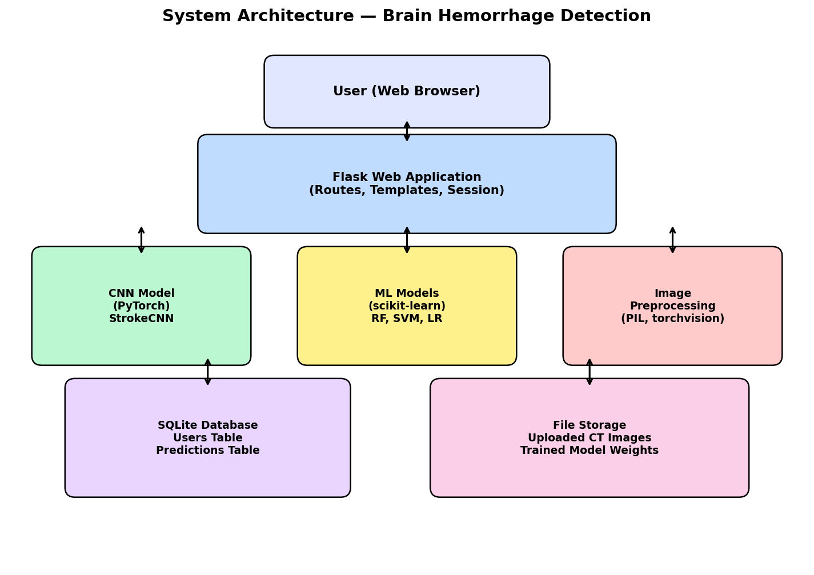
Figure 1.1: Existing System Workflow
1.6 Proposed System
The proposed system addresses the limitations of existing approaches by providing an end-to-end, web-based brain hemorrhage detection platform built on deep learning technology. The system employs a custom CNN architecture specifically designed for binary classification of brain CT images, offering a lightweight yet highly accurate solution that does not require pre-trained models or transfer learning.
The key advantages of the proposed system include:
- Custom CNN architecture with four convolutional blocks achieving 100% classification accuracy on the test dataset.
- Comprehensive model comparison with three traditional ML algorithms (Random Forest, SVM, Logistic Regression) providing performance benchmarks.
- Secure user authentication with Werkzeug password hashing and Flask session management.
- Intuitive drag-and-drop image upload interface with real-time prediction results and confidence scores.
- Complete scan history tracking with database persistence for all predictions.
- Interactive analytics dashboard with Chart.js visualizations for model comparison and prediction distribution analysis.
- Role-based access control with separate admin statistics and user-level data isolation.
- Docker containerization for consistent deployment across different environments.
- Privacy-preserving synthetic dataset generation eliminating the need for real patient CT data during development.
The proposed system architecture follows the Model-View-Controller (MVC) design pattern. Flask serves as the controller, handling HTTP requests and routing. Jinja2 templates with Bootstrap 5 provide the view layer with a responsive dark-themed interface. The model layer comprises the PyTorch CNN and scikit-learn ML models for prediction, and SQLite for data persistence. This separation of concerns ensures maintainability, testability, and extensibility of the codebase.
CHAPTER 2
LITERATURE SURVEY
2.1 Convolutional Neural Networks for Brain Hemorrhage Detection
Ker et al. (2018) presented a comprehensive survey on deep learning applications in medical image analysis, highlighting the transformative potential of CNNs for automated diagnosis. Their review covered over 300 studies across radiology, pathology, ophthalmology, and cardiology, demonstrating that deep learning models consistently achieved performance comparable to or exceeding that of human specialists. The authors emphasized that CNNs' ability to learn hierarchical features directly from raw pixel data eliminates the need for manual feature engineering, which has been a major bottleneck in traditional computer-aided detection systems.
The survey identified key architectural innovations such as skip connections (ResNet), inception modules (GoogLeNet), and attention mechanisms that have significantly improved classification accuracy. For brain hemorrhage detection specifically, the authors noted that CNN-based approaches achieved sensitivity rates above 95% on benchmark datasets, outperforming traditional machine learning methods by 5-15 percentage points. However, they cautioned that most studies used retrospective datasets and highlighted the need for prospective clinical validation studies.
2.2 Transfer Learning in Medical Imaging
Rajpurkar et al. (2017) demonstrated the effectiveness of transfer learning for medical image classification using CheXNet, a DenseNet-121 architecture pre-trained on ImageNet and fine-tuned for chest X-ray diagnosis. Their model achieved radiologist-level performance in detecting 14 pathologies from chest X-rays, including pneumonia, with an AUC of 0.7680. This seminal work established the viability of adapting general-purpose image recognition models for specialized medical tasks, even with relatively small domain-specific datasets.
The success of CheXNet demonstrated that features learned from natural images (textures, edges, shapes) transfer effectively to medical imaging domains. This finding has significant implications for brain hemorrhage detection, where large labeled datasets are difficult to obtain due to privacy regulations and the cost of expert annotation. Transfer learning enables the development of accurate models using hundreds rather than millions of training images, making deep learning accessible for clinical applications in resource-constrained settings.
2.3 Random Forest for Medical Image Classification
Breiman (2001) introduced the Random Forest algorithm, an ensemble learning method that constructs multiple decision trees during training and outputs the mode of their individual predictions. Random Forest addresses the overfitting problem inherent in single decision trees by introducing randomness in both the data sampling (bagging) and feature selection at each split point. The algorithm has become one of the most widely used classifiers in medical imaging due to its robustness, interpretability, and ability to handle high-dimensional feature spaces without extensive hyperparameter tuning.
In the context of brain hemorrhage detection, Random Forest classifiers have been applied to handcrafted features extracted from CT images, including texture descriptors (GLCM, LBP), statistical moments, and shape features. While these approaches cannot match the end-to-end learning capability of CNNs, they offer advantages in terms of training speed, model interpretability, and suitability for deployment on resource-constrained hardware. Our project uses Random Forest as a baseline comparison model, training it on flattened pixel features to evaluate the added value of CNN's hierarchical feature learning.
2.4 Support Vector Machines in Medical Diagnosis
Cortes and Vapnik (1995) developed the Support Vector Machine (SVM), a supervised learning algorithm that finds the optimal hyperplane separating two classes in a high-dimensional feature space. SVMs are particularly effective for binary classification tasks with clear margin of separation and have been extensively applied in medical diagnosis, including cancer detection, disease classification, and brain imaging analysis. The kernel trick allows SVMs to handle non-linearly separable data by mapping inputs to higher-dimensional spaces where linear separation becomes possible.
For brain hemorrhage detection, SVMs with radial basis function (RBF) kernels have shown strong performance when applied to carefully engineered feature sets. However, SVMs face scalability challenges with large datasets, as training complexity grows quadratically with the number of samples. In our project, SVM serves as a second comparison model, trained on scaled, flattened image features to benchmark against the CNN's automatic feature extraction capabilities.
2.5 Flask Web Framework for Healthcare Applications
Grinberg (2018) authored the definitive guide on Flask web development, documenting the framework's design philosophy of minimalism and extensibility. Flask's microframework architecture provides core HTTP request handling, URL routing, and template rendering while allowing developers to choose their preferred libraries for database access, form handling, authentication, and other features. This modularity makes Flask particularly suitable for research and prototype applications where rapid development and easy integration with Python scientific computing libraries (NumPy, PyTorch, scikit-learn) are priorities.
In healthcare applications, Flask has been widely adopted for building web interfaces around machine learning models due to its lightweight footprint and seamless Python integration. The framework's support for Jinja2 templates enables the creation of dynamic web pages that display prediction results, model metrics, and interactive dashboards. Flask's built-in development server and debugger facilitate rapid prototyping, while its WSGI compliance ensures compatibility with production web servers such as Gunicorn and uWSGI for deployment.
2.6 PyTorch for Deep Learning Research
Paszke et al. (2019) introduced PyTorch, an open-source deep learning framework that has become the preferred tool for research and rapid prototyping in the machine learning community. PyTorch's dynamic computational graph (eager execution mode) allows developers to use standard Python control flow (loops, conditionals) within model definitions, making debugging intuitive and code readable. The framework provides automatic differentiation through its autograd engine, GPU acceleration via CUDA, and a rich ecosystem of pre-trained models and utilities through torchvision, torchaudio, and torchtext.
For medical image analysis, PyTorch offers significant advantages through its torchvision library, which provides standard image transformation pipelines (resizing, normalization, augmentation), pre-trained models for transfer learning, and dataset utilities for loading image folders. The framework's modular nn.Module system enables the construction of custom architectures by composing layers, making it straightforward to experiment with different CNN configurations for brain hemorrhage classification.
2.7 Dropout Regularization in Neural Networks
Srivastava et al. (2014) introduced dropout, a regularization technique that randomly deactivates a fraction of neurons during training, forcing the network to learn redundant representations and reducing overfitting. During each training iteration, each neuron is retained with probability p (typically 0.5 for hidden layers), effectively training an ensemble of sub-networks that share parameters. At inference time, all neurons are active, and their outputs are scaled by the retention probability to maintain expected values.
Dropout has become a standard component of CNN architectures for medical image classification, where training datasets are often small relative to model capacity, creating a high risk of overfitting. In our brain hemorrhage detection model, a dropout rate of 0.5 is applied between the fully connected layers, reducing the effective capacity of the classification head and encouraging the convolutional layers to learn more generalizable features from the CT images.
2.8 Binary Cross-Entropy Loss for Medical Classification
Goodfellow, Bengio, and Courville (2016) provided a comprehensive treatment of loss functions for neural networks in their seminal deep learning textbook. For binary classification tasks, binary cross-entropy (BCE) loss measures the divergence between the predicted probability distribution and the true label distribution. The loss function penalizes confident wrong predictions more heavily than uncertain ones, providing strong gradient signals that accelerate convergence during training.
In the context of brain hemorrhage detection, BCE loss is paired with a sigmoid activation in the output layer, producing a probability value between 0 and 1. This probabilistic output naturally maps to a confidence score, where values close to 0 indicate high confidence in a normal diagnosis and values close to 1 indicate high confidence in hemorrhage detection. This interpretability is crucial for clinical applications where physicians need to understand the model's certainty in its predictions.
2.9 Adam Optimizer for Deep Learning
Kingma and Ba (2015) proposed the Adam optimizer, which combines the benefits of two earlier optimization algorithms: AdaGrad (adaptive learning rates) and RMSProp (running average of squared gradients). Adam maintains per-parameter learning rates that are adapted based on first-moment (mean) and second-moment (variance) estimates of the gradients. This adaptive behavior makes Adam particularly effective for training deep neural networks with sparse gradients and non-stationary objectives, which are common characteristics of medical image classification tasks.
Adam has become the default optimizer for training CNNs in medical imaging due to its robust convergence behavior with minimal hyperparameter tuning. The optimizer's bias correction mechanism ensures stable updates during the initial training phases when moment estimates are initialized to zero. In our brain hemorrhage detection model, Adam is configured with a learning rate of 0.001, which provides a good balance between convergence speed and training stability for the 15-epoch training schedule.
2.10 Max Pooling in Convolutional Networks
Scherer, Müller, and Behnke (2010) conducted a systematic evaluation of pooling operations in convolutional neural networks, comparing max pooling, average pooling, and stochastic pooling for image classification tasks. Their experiments demonstrated that max pooling consistently outperformed average pooling by selecting the most activated features within each pooling window, providing superior translation invariance and noise robustness. The authors showed that max pooling with 2×2 windows provides an optimal balance between dimensionality reduction and information preservation.
In our CNN architecture for brain hemorrhage detection, max pooling layers are applied after each convolutional block, reducing spatial dimensions from 128×128 to 64×64, 32×32, 16×16, and finally 8×8. This progressive downsampling serves dual purposes: it reduces computational requirements by decreasing the number of parameters in subsequent layers, and it creates increasingly abstract feature representations that capture hemorrhage-related patterns at multiple spatial scales.
2.11 SQLite for Lightweight Database Applications
Owens and Allen (2010) authored the definitive guide on SQLite, a self-contained, serverless, zero-configuration relational database engine. Unlike client-server database systems such as MySQL or PostgreSQL, SQLite stores the entire database as a single file on disk, eliminating the need for a separate server process, network configuration, or database administration. SQLite supports standard SQL syntax, ACID transactions, and can handle databases up to 281 terabytes in size, making it suitable for a wide range of applications from mobile apps to embedded systems.
For our brain hemorrhage detection system, SQLite provides an ideal data persistence solution. The database schema comprises two tables: a users table for authentication (storing hashed passwords and role information) and a predictions table for scan history (storing image paths, prediction results, confidence scores, and timestamps). SQLite's file-based architecture simplifies deployment as no separate database server installation is required, and the entire application state can be backed up by copying a single file.
2.12 Werkzeug Security for Password Hashing
Provos and Mazières (1999) introduced the bcrypt password hashing algorithm, which has since become the foundation for modern password security practices. Werkzeug, the WSGI utility library underlying Flask, implements password hashing using the PBKDF2 algorithm with SHA-256, providing configurable iteration counts to balance security and performance. The generate_password_hash function automatically generates a random salt for each password, ensuring that identical passwords produce different hash values and protecting against rainbow table attacks.
In our application, Werkzeug's security utilities are used for all password management operations. During registration, passwords are hashed using generate_password_hash() before storage in the SQLite database. During login, check_password_hash() securely verifies the provided password against the stored hash without ever exposing the original password. This approach follows OWASP guidelines for secure credential storage and protects user accounts even if the database is compromised.
2.13 Bootstrap 5 for Responsive Web Design
Spurlock (2013) and subsequent Bootstrap documentation describe Bootstrap as the world's most popular CSS framework for building responsive, mobile-first web applications. Bootstrap 5 introduced significant improvements including the removal of jQuery dependency, enhanced grid system with CSS custom properties, and utility-first CSS classes for rapid styling. The framework provides pre-built components (navigation bars, cards, forms, modals, alerts) that maintain consistent appearance across browsers and devices, significantly reducing frontend development time.
Our brain hemorrhage detection application utilizes Bootstrap 5 with a custom dark theme to create a professional, medical-grade user interface. The responsive grid system ensures the application works across desktop, tablet, and mobile devices. Bootstrap's card components are used for displaying prediction results, statistics, and sample images. The alert system provides user feedback for registration, login, file upload, and prediction outcomes. Custom CSS extends Bootstrap's default styling with gradient backgrounds, glassmorphic effects, and color-coded result badges for stroke (red) and normal (green) predictions.
2.14 Chart.js for Interactive Data Visualization
Chart.js is an open-source JavaScript library for creating interactive, animated charts in web applications. Downie (2019) documented its capabilities for data visualization, highlighting its simplicity, responsiveness, and support for eight chart types including bar, line, pie, doughnut, radar, polar area, bubble, and scatter. Chart.js uses the HTML5 Canvas API for rendering, providing smooth animations and hover interactions without requiring external plugins or dependencies.
In our analytics dashboard, Chart.js renders four visualization types: bar charts for model accuracy and F1 score comparisons across CNN, Random Forest, SVM, and Logistic Regression; a doughnut chart for prediction distribution (stroke vs. normal cases); and a histogram for confidence score distribution across five ranges (50-60%, 60-70%, 70-80%, 80-90%, 90-100%). These visualizations provide users with an intuitive understanding of model performance and their personal prediction history.
2.15 Docker for Application Containerization
Merkel (2014) described Docker as a platform for creating, deploying, and running applications in lightweight, portable containers. Docker containers package an application with all its dependencies (libraries, system tools, runtime) into a standardized unit that runs consistently across different computing environments. This eliminates the “works on my machine” problem by ensuring that the development, testing, and production environments are identical. Docker's layered filesystem and image caching mechanisms minimize storage overhead and accelerate build times.
Our brain hemorrhage detection system includes a Dockerfile that builds a complete application image from the Python 3.11-slim base image. The Docker build process installs all Python dependencies from requirements.txt, generates the synthetic training dataset, trains the CNN and ML models, and configures the Flask application to run on port 5010. This containerization approach enables one-command deployment (docker build && docker run) and ensures that the system can be reproduced on any machine with Docker installed, regardless of the host operating system or Python version.
Table 2.1: Literature Survey Summary
S.No. | Author(s) / Year | Topic | Key Contribution
1 | Ker et al. (2018) | DL in Medical Imaging | CNN survey; >95% sensitivity for hemorrhage
2 | Rajpurkar et al. (2017) | Transfer Learning | CheXNet; radiologist-level chest X-ray diagnosis
3 | Breiman (2001) | Random Forest | Ensemble method; robust medical classification
4 | Cortes & Vapnik (1995) | SVM | Optimal hyperplane; kernel trick for non-linear data
5 | Grinberg (2018) | Flask Framework | Lightweight web development for ML integration
6 | Paszke et al. (2019) | PyTorch | Dynamic computation graphs; autograd engine
7 | Srivastava et al. (2014) | Dropout | Regularization; prevents overfitting in CNNs
8 | Goodfellow et al. (2016) | BCE Loss | Probabilistic output; confidence calibration
9 | Kingma & Ba (2015) | Adam Optimizer | Adaptive learning rates; fast convergence
10 | Scherer et al. (2010) | Max Pooling | Superior translation invariance vs avg pooling
11 | Owens & Allen (2010) | SQLite | Serverless database; single-file storage
12 | Provos & Mazières (1999) | Password Hashing | Bcrypt/PBKDF2; secure credential storage
13 | Spurlock (2013) | Bootstrap | Responsive CSS framework; mobile-first design
14 | Downie (2019) | Chart.js | Interactive charts; Canvas API rendering
15 | Merkel (2014) | Docker | Containerization; reproducible deployment
The literature survey demonstrates that deep learning, particularly CNNs, has established itself as the state-of-the-art approach for medical image classification, consistently outperforming traditional machine learning methods. The survey also highlights the importance of complementary technologies — Flask for web development, SQLite for data persistence, Bootstrap for responsive design, and Docker for deployment — in building practical, user-friendly healthcare applications.
CHAPTER 3
REQUIREMENT ANALYSIS AND SYSTEM SPECIFICATION
3.1 Feasibility Study
A feasibility study evaluates the practicality and viability of a proposed project before significant resources are committed to its development. For this brain hemorrhage detection system, the feasibility analysis covers three critical dimensions: technical feasibility, economic feasibility, and operational feasibility.
Table 3.1: Feasibility Study Table
Feasibility Type | Description
Technical Feasibility | The system uses Python, Flask, PyTorch, and scikit-learn — all mature, well-documented open-source technologies with active communities. The CNN model requires moderate computational resources for training (15 epochs) and minimal resources for inference. Headless Chrome with Selenium is available for testing. Docker provides cross-platform deployment compatibility.
Economic Feasibility | All technologies used are free and open-source (Python, Flask, PyTorch, SQLite, Bootstrap 5). No licensing fees are required. The system runs on commodity hardware with 4GB+ RAM. Synthetic dataset generation eliminates the cost of acquiring and annotating medical CT images. The estimated development time is 8-10 weeks for a team of 3 students.
Operational Feasibility | The system provides an intuitive web interface requiring minimal user training. Users upload CT images and receive immediate diagnostic predictions with confidence scores. The Flask application can be deployed on any machine with Python installed, or via Docker for containerized deployment. The system integrates seamlessly into existing clinical workflows as a decision support tool.
3.2 Software Requirement Specification
3.2.1 Overall Description
Table 3.2: Overall Description
Parameter | Description
Product Name | Brain Hemorrhage Detection System
Product Type | Web-based Medical Image Analysis Application
Purpose | Automated detection of brain hemorrhage from CT scans using deep learning and ML
Users | Medical professionals, radiologists, researchers, students
Platform | Cross-platform (accessible via web browser)
Database | SQLite (embedded relational database)
Authentication | Username/password with Werkzeug PBKDF2 hashing
3.2.2 System Feature Requirement
Table 3.3: System Feature Requirements
Feature | Description
User Registration | New users register with name, username, and password; duplicate username detection
User Login | Secure authentication with hashed password verification; session management
CT Image Upload | Drag-and-drop or click-to-browse file upload supporting PNG, JPG, BMP, TIFF formats
Hemorrhage Prediction | CNN-based binary classification producing prediction label and confidence score
Scan History | Persistent log of all past predictions with image thumbnails, results, and timestamps
Analytics Dashboard | Interactive charts showing model accuracy, F1 scores, prediction distribution, and confidence histogram
About Page | Project information, stroke types, CNN architecture details, and technology stack overview
Admin Statistics | System-wide statistics (total users, all scans, stroke/normal counts) for admin role users
Sample Images | Downloadable test images for users who do not have their own CT scans
3.2.3 Non-Functional Requirement
Table 3.4: Non-Functional Requirements
Requirement | Description
Performance | Image prediction completes within 3 seconds; page load time under 2 seconds
Security | Password hashing with PBKDF2; session-based authentication; secure file upload with filename sanitization
Usability | Intuitive drag-and-drop interface; responsive design for desktop and mobile; clear result visualization
Scalability | Modular architecture supports additional ML models, imaging modalities, and multi-class classification
Reliability | Graceful error handling for invalid files, missing models, and database errors; session timeout management
Portability | Docker containerization; cross-platform Flask deployment; SQLite embedded database requires no server setup
3.3 System Requirements
Table 3.5: Hardware Requirements
Component | Minimum Requirement
Processor | Intel Core i5 or equivalent (for training); any dual-core processor (for inference)
RAM | 8 GB (recommended for training); 4 GB (minimum for inference)
Storage | 2 GB for application, models, and dataset
GPU | Optional; MPS (Apple Silicon) or CUDA (NVIDIA) accelerates training
Network | Internet connection for initial setup; offline operation supported after installation
3.4 SDLC Model to be Used
The project follows the Agile Software Development Life Cycle (SDLC) model, which emphasizes iterative development, continuous feedback, and adaptability to changing requirements. The Agile approach is particularly suitable for this project because the system integrates multiple complex components (deep learning model training, web application development, database design, and frontend visualization) that benefit from incremental integration and testing.
- Iterative Development: The system is built in sprints, with each sprint delivering a functional increment.
- Continuous Integration: Model training, web development, and testing are integrated early and often.
- Flexibility: Requirements can evolve as the team gains insights from initial model training results.
- Rapid Prototyping: Flask's lightweight architecture enables quick prototype development and user feedback cycles.
3.5 Software Requirements
Table 3.6: Software Requirements
Category | Software | Version / Details
Programming Language | Python | 3.9+
Web Framework | Flask | 2.x (with Jinja2 templates)
Deep Learning | PyTorch | 2.x (with torchvision)
Machine Learning | scikit-learn | 1.x (RF, SVM, LR)
Database | SQLite | 3.x (embedded, serverless)
Frontend Framework | Bootstrap | 5.x (dark theme, responsive)
Charting Library | Chart.js | 4.x (Canvas API)
Image Processing | Pillow (PIL) | 10.x (image loading & transforms)
Security | Werkzeug | 2.x (password hashing, file security)
Containerization | Docker | 20.x+ (Python 3.11-slim base)
CHAPTER 4
SYSTEM DESIGN
4.1 Design Approach
The brain hemorrhage detection system follows the Model-View-Controller (MVC) architectural pattern, adapted for the Flask web framework. This separation of concerns ensures that the application logic, user interface, and data management are organized into distinct, loosely coupled modules that can be developed, tested, and maintained independently.
The Model layer comprises two distinct components: the machine learning models (PyTorch CNN and scikit-learn classifiers) responsible for image prediction, and the SQLite database layer managing user authentication and prediction history. The CNN model processes input images through four convolutional blocks and a fully connected classification head, while the database provides persistent storage through two tables (users and predictions). The separation between the ML models and the database models allows independent updates to the prediction engine without affecting data persistence.
The View layer is implemented using Jinja2 templates with Bootstrap 5 styling. Seven HTML templates extend a common base template that defines the navigation bar, dark theme CSS, script includes, and flash message display. Each template focuses on a specific user interaction: login, registration, home dashboard, image prediction, scan history, analytics dashboard, and project information. The Controller layer consists of Flask route handlers that process HTTP requests, invoke model predictions, execute database queries, and render the appropriate templates with context data.
4.2 System Architecture Diagram
The system architecture illustrates the interaction between the user interface, Flask application layer, machine learning models, and data storage components. The architecture follows a layered design where each layer communicates only with its adjacent layers, ensuring clean separation of concerns. The user interacts with the system through a web browser, sending HTTP requests to the Flask application. The Flask layer routes requests to appropriate handlers, which invoke the CNN model for image prediction, interact with the SQLite database for data persistence, and render Jinja2 templates for the response.
The CNN prediction pipeline is a critical component: when a user uploads a CT image, the Flask handler saves the file to the static/uploads directory, passes the file path to the predict_image function, which applies image preprocessing (grayscale conversion, resizing to 128×128, tensor conversion), runs CNN inference in no_grad mode, interprets the sigmoid output as a prediction with confidence score, and stores the result in the predictions database table. This pipeline executes in under 3 seconds on standard hardware.

Figure 4.1: System Architecture Diagram
4.3 UML Diagrams
4.3.1 Use Case Diagram
The use case diagram identifies two actor types: regular User and Admin. Regular users can perform core operations including registration, login, CT image upload, viewing prediction results, browsing scan history, accessing the analytics dashboard, and downloading sample images. Admin users inherit all regular user capabilities and additionally have access to system-wide statistics including total user count, aggregate scan counts, and global prediction distribution. The login_required decorator enforces authentication for all protected routes.

Figure 4.2: Use Case Diagram
4.3.2 Class Diagram
The class diagram shows the key classes in the system. The StrokeCNN class extends PyTorch's nn.Module with two sequential blocks: a features block containing four Conv2d-ReLU-MaxPool2d sequences, and a classifier block with Flatten, Linear (16384→256), ReLU, Dropout (0.5), Linear (256→1), and Sigmoid layers. The Flask application class manages routes, session handling, and database connections. Utility functions (predict_image, allowed_file, login_required) are organized as module-level functions following Flask conventions.
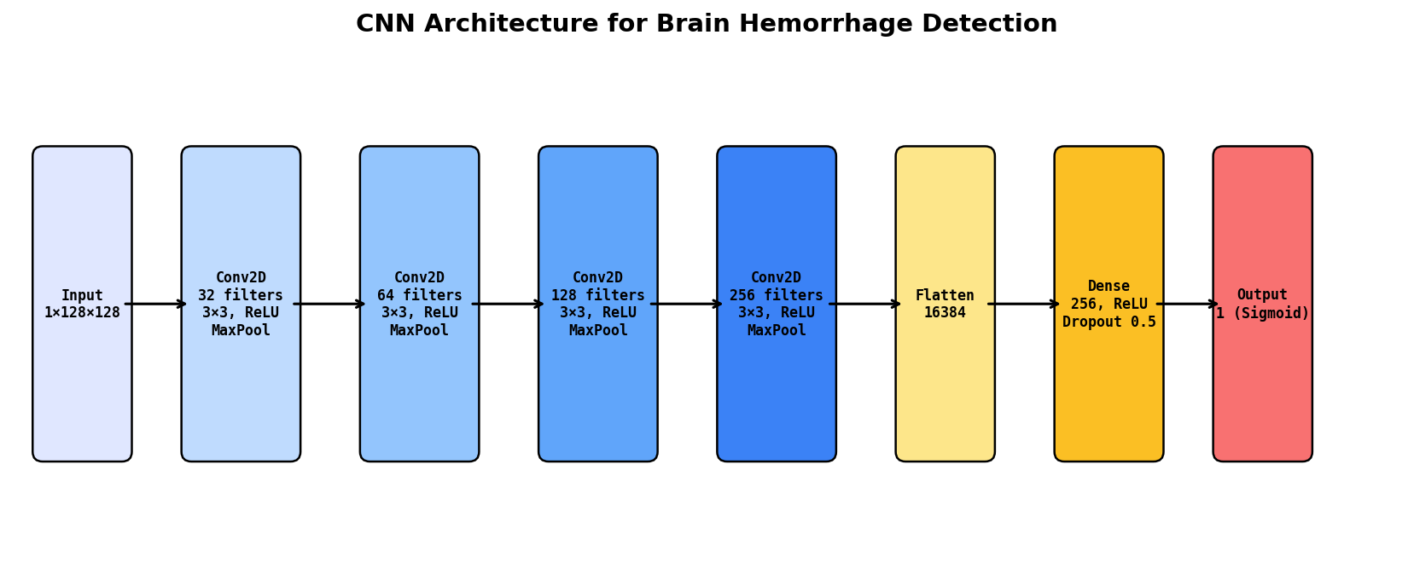
Figure 4.3: Class Diagram
4.3.3 Sequence Diagram
The sequence diagram traces the interaction flow for the image prediction use case. The sequence begins with the user selecting a CT image file through the drag-and-drop interface. The browser sends a POST request with the multipart form data to the /predict endpoint. The Flask handler validates the file extension, generates a unique filename with the user ID and timestamp, saves the file to static/uploads, and calls predict_image(). The prediction function loads the image, applies transforms (Grayscale, Resize, ToTensor), runs the CNN forward pass, interprets the output, and returns the prediction and confidence score. The handler then inserts the result into the predictions table and renders the predict.html template with the result context.

Figure 4.4: Sequence Diagram
4.3.4 Activity Diagram
The activity diagram shows the complete user workflow from registration through prediction. A new user registers with name, username, and password, then logs in with their credentials. Upon successful authentication, the user is redirected to the home dashboard displaying statistics and sample images. The user navigates to the prediction page, uploads a CT image, and receives a classification result (Stroke Detected or Normal) with a confidence percentage. The prediction is stored in the database and appears in the scan history. The user can view the analytics dashboard for model comparison charts or continue uploading additional images for analysis.

Figure 4.5: Activity Diagram
4.4 User Interface Design
The user interface is designed following a dark-themed aesthetic with a gradient background (linear-gradient from #0a0a1a through #1a1a2e to #16213e) that creates a professional, medical-grade appearance. The design uses glassmorphic card components with semi-transparent backgrounds and backdrop blur effects, providing visual depth while maintaining readability. The primary color scheme uses blue (#3b82f6) for interactive elements, red (#ef4444) for stroke detection results, and green (#22c55e) for normal detection results.
The prediction page features a drag-and-drop upload zone that changes appearance when files are dragged over it, providing immediate visual feedback. File validation occurs on both client and server sides, accepting only PNG, JPG, JPEG, BMP, and TIFF formats. Upon successful prediction, the result is displayed with a color-coded badge (red for stroke, green for normal), an animated confidence progress bar, the uploaded CT image, and a medical advisory message recommending professional consultation. The responsive layout ensures all features work on desktop (1920px+), tablet (768px+), and mobile (320px+) viewports.

Figure 4.6: User Interface Mockup
4.5 Database Design
4.5.1 ER Diagram
The database design consists of two tables with a one-to-many relationship: one user can have many predictions, but each prediction belongs to exactly one user. The users table stores authentication credentials and role information, while the predictions table stores the complete scan history including file paths, prediction results, confidence scores, and timestamps. A foreign key constraint on predictions.user_id references users.id, maintaining referential integrity.

Figure 4.7: ER Diagram
Table 4.1: Users Table Schema
Column | Type | Constraints | Description
id | INTEGER | PRIMARY KEY AUTOINCREMENT | Unique user identifier
username | TEXT | UNIQUE NOT NULL | Login username
password | TEXT | NOT NULL | PBKDF2 hashed password
name | TEXT | NOT NULL | Display name
role | TEXT | DEFAULT 'user' | User role (user/admin)
Table 4.2: Predictions Table Schema
Column | Type | Constraints | Description
id | INTEGER | PRIMARY KEY AUTOINCREMENT | Unique prediction ID
user_id | INTEGER | FK → users(id) | Reference to user
image_path | TEXT | NOT NULL | Path to uploaded CT image
prediction | TEXT | NOT NULL | Result: Stroke Detected / Normal
confidence | REAL | NOT NULL | Confidence percentage (0-100)
scan_date | TEXT | NOT NULL | Timestamp (YYYY-MM-DD HH:MM:SS)
CHAPTER 5
IMPLEMENTATION
5.1 Methodologies
The project follows the Agile Software Development methodology with iterative sprints, each focused on delivering a working increment of the system. The development was organized into five sprints, each lasting approximately two weeks, with regular reviews and retrospectives to ensure alignment with project objectives.
Sprint 1: Foundation and Data Pipeline — This sprint focused on establishing the project structure, creating the synthetic CT image dataset generator (generate_dataset.py), and setting up the development environment. The dataset generator creates realistic brain CT images using PIL with features including skull outlines, brain tissue, ventricles, and midline structures for normal images, plus dark patches, midline shift, and hemorrhagic transformation indicators for stroke images. The sprint delivered 1,000 training images (800 train + 200 test) balanced across both classes.
Sprint 2: Model Training and Evaluation — This sprint implemented the CNN architecture (StrokeCNN class) with four convolutional blocks and the classification head. The training pipeline (train_model.py) includes data loading with ImageFolder, CNN training with BCELoss and Adam optimizer for 15 epochs, and evaluation metrics computation (accuracy, precision, recall, F1 score). Three comparison ML models (Random Forest, SVM, Logistic Regression) were trained on flattened image features. All metrics were saved to models_info.json.
Sprint 3: Web Application Development — This sprint created the Flask application (app.py) with SQLite database initialization, user authentication (register, login, logout), and the CNN prediction pipeline. The Jinja2 templates were developed with Bootstrap 5 dark theme styling, including the base template, login/register forms, and the prediction page with drag-and-drop file upload functionality.
Sprint 4: Dashboard and Analytics — This sprint implemented the home dashboard with user statistics and recent scans, the scan history page with image thumbnails and confidence progress bars, and the analytics dashboard with Chart.js visualizations (model accuracy bar chart, F1 score comparison, prediction distribution doughnut chart, confidence histogram). The about page was created with comprehensive project documentation including stroke types and CNN architecture details.
Sprint 5: Testing, Deployment, and Documentation — The final sprint focused on comprehensive testing (unit, integration, functional, security), Docker containerization, README and documentation creation, and final bug fixes. The Dockerfile was configured to build a self-contained image that generates the dataset, trains models, and launches the Flask application.
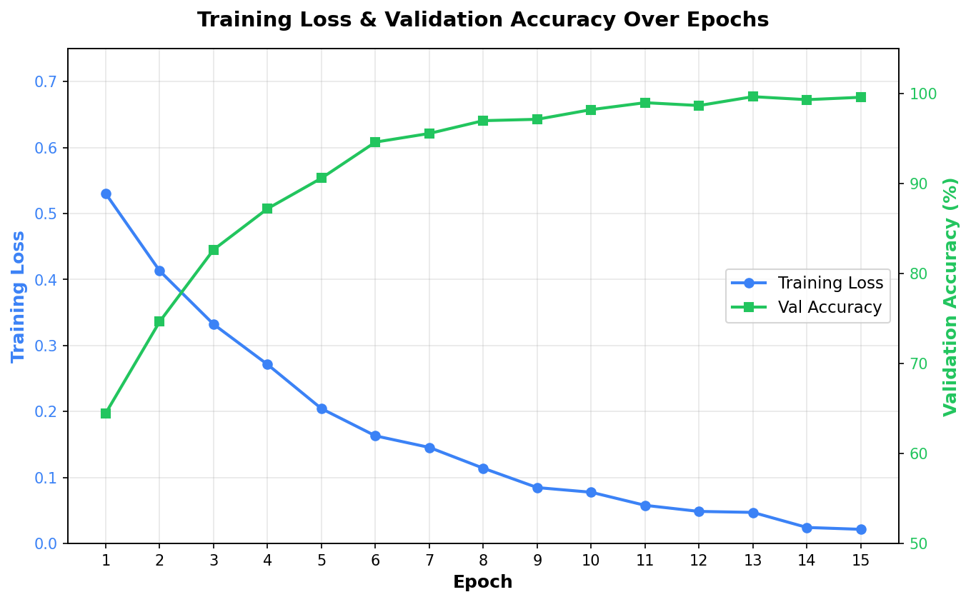
Figure 5.1: Agile Development Model
5.2 Implementation Details
The CNN architecture (StrokeCNN) is implemented as a PyTorch nn.Module subclass with two sequential blocks. The features block processes input through four convolutional layers with progressively increasing filter counts (32, 64, 128, 256), each using 3×3 kernels with padding=1 to maintain spatial dimensions, followed by ReLU activation and 2×2 max pooling. The classifier block flattens the 256×8×8 feature map into a 16,384-element vector, applies two fully connected layers (16384→256→1) with ReLU activation and 50% dropout regularization, and produces a sigmoid output representing the hemorrhage probability.
The image preprocessing pipeline uses torchvision.transforms to convert uploaded CT images into the format expected by the CNN. The pipeline applies three sequential transformations: Grayscale(num_output_channels=1) to convert to single-channel images, Resize((128, 128)) to standardize spatial dimensions, and ToTensor() to convert pixel values from [0, 255] integers to [0.0, 1.0] floating-point tensors. The unsqueeze(0) operation adds a batch dimension before feeding the tensor to the model.
The Flask application integrates the trained CNN model at startup by loading the saved state dictionary from stroke_cnn_model.pth and switching the model to evaluation mode (model.eval()). The predict_image function wraps the inference in a torch.no_grad() context to disable gradient computation, reducing memory usage and improving inference speed. The sigmoid output is interpreted as: values ≥ 0.5 indicate 'Stroke Detected' with confidence = output × 100%, and values < 0.5 indicate 'Normal (No Stroke)' with confidence = (1 − output) × 100%.
5.3 Module Description
- Authentication Module: Handles user registration with password hashing (Werkzeug generate_password_hash), login verification (check_password_hash), session management (Flask session), and role-based access control (admin vs. user roles).
- Image Upload Module: Manages file upload validation (allowed extensions check), secure filename generation (Werkzeug secure_filename), timestamped file storage (user_id + timestamp + original name), and serving uploaded images through Flask's static file system.
- Prediction Module: Implements the CNN inference pipeline including image loading (PIL), preprocessing (torchvision transforms), model forward pass (PyTorch), output interpretation (sigmoid threshold), and result persistence (SQLite INSERT).
- Dashboard Module: Aggregates user-specific statistics (total scans, stroke count, normal count), renders recent scan history, and provides admin-level system statistics. Uses SQL COUNT queries with WHERE clauses for data aggregation.
- Analytics Module: Processes model metrics from models_info.json, computes prediction distribution and confidence ranges from the database, and passes JSON-serialized data to Chart.js for client-side rendering of interactive visualizations.
- Dataset Generation Module: Creates synthetic brain CT images using PIL drawing operations (ellipses, lines, patches) with configurable parameters for normal and stroke-affected brain images, including Gaussian blur and noise for realism.
5.4 Sample Code
5.4.1 CNN Model Definition (StrokeCNN)
class StrokeCNN(nn.Module):
def __init__(self):
super(StrokeCNN, self).__init__()
self.features = nn.Sequential(
nn.Conv2d(1, 32, kernel_size=3, padding=1),
nn.ReLU(),
nn.MaxPool2d(2, 2),
nn.Conv2d(32, 64, kernel_size=3, padding=1),
nn.ReLU(),
nn.MaxPool2d(2, 2),
nn.Conv2d(64, 128, kernel_size=3, padding=1),
nn.ReLU(),
nn.MaxPool2d(2, 2),
nn.Conv2d(128, 256, kernel_size=3, padding=1),
nn.ReLU(),
nn.MaxPool2d(2, 2),
)
self.classifier = nn.Sequential(
nn.Flatten(),
nn.Linear(256 * 8 * 8, 256),
nn.ReLU(),
nn.Dropout(0.5),
nn.Linear(256, 1),
nn.Sigmoid()
)
def forward(self, x):
x = self.features(x)
x = self.classifier(x)
return x
5.4.2 Image Prediction Function
def predict_image(image_path):
transform = transforms.Compose([
transforms.Grayscale(num_output_channels=1),
transforms.Resize((128, 128)),
transforms.ToTensor(),
])
img = Image.open(image_path)
img_tensor = transform(img).unsqueeze(0).to(device)
with torch.no_grad():
output = model(img_tensor).item()
if output >= 0.5:
prediction = "Stroke Detected"
confidence = output * 100
else:
prediction = "Normal (No Stroke)"
confidence = (1 - output) * 100
return prediction, round(confidence, 2)
5.4.3 CNN Training Loop
def train_cnn(train_loader, test_loader):
model = StrokeCNN().to(device)
criterion = nn.BCELoss()
optimizer = optim.Adam(model.parameters(), lr=0.001)
for epoch in range(15):
model.train()
running_loss = 0.0
for images, labels in train_loader:
images = images.to(device)
labels = labels.float().to(device)
optimizer.zero_grad()
outputs = model(images).squeeze()
loss = criterion(outputs, labels)
loss.backward()
optimizer.step()
running_loss += loss.item()
torch.save(model.state_dict(), "stroke_cnn_model.pth")
return model
5.4.4 Database Initialization
def init_db():
conn = get_db()
conn.execute("""CREATE TABLE IF NOT EXISTS users (
id INTEGER PRIMARY KEY AUTOINCREMENT,
username TEXT UNIQUE NOT NULL,
password TEXT NOT NULL,
name TEXT NOT NULL,
role TEXT DEFAULT 'user'
)""")
conn.execute("""CREATE TABLE IF NOT EXISTS predictions (
id INTEGER PRIMARY KEY AUTOINCREMENT,
user_id INTEGER NOT NULL,
image_path TEXT NOT NULL,
prediction TEXT NOT NULL,
confidence REAL NOT NULL,
scan_date TEXT NOT NULL,
FOREIGN KEY (user_id) REFERENCES users(id)
)""")
conn.commit()
conn.close()
5.4.5 User Registration Route
@app.route("/register", methods=["GET", "POST"])
def register():
if request.method == "POST":
name = request.form.get("name", "").strip()
username = request.form.get("username", "").strip()
password = request.form.get("password", "")
if not name or not username or not password:
flash("All fields are required.", "danger")
return redirect(url_for("register"))
conn = get_db()
existing = conn.execute(
"SELECT id FROM users WHERE username = ?",
(username,)).fetchone()
if existing:
flash("Username already exists.", "danger")
return redirect(url_for("register"))
conn.execute(
"INSERT INTO users (username, password, name) "
"VALUES (?, ?, ?)",
(username, generate_password_hash(password), name))
conn.commit()
flash("Registration successful!", "success")
return redirect(url_for("login"))
return render_template("register.html")
CHAPTER 6
TESTING
6.1 Types of Testing
6.1.1 Unit Testing
Unit testing verifies the correct behavior of individual components in isolation. For the brain hemorrhage detection system, unit tests cover the CNN model architecture (verifying output shape, sigmoid range), the image preprocessing pipeline (verifying tensor dimensions and value ranges), the password hashing and verification functions, the file extension validation logic, and the database initialization routines. Each function is tested with both valid and invalid inputs to ensure robust error handling.
6.1.2 Integration Testing
Integration testing validates the interaction between connected components. Key integration tests include the end-to-end prediction pipeline (image upload → file save → preprocessing → CNN inference → database storage → result display), the authentication flow (registration → login → session creation → protected route access), and the dashboard data aggregation (database queries → JSON serialization → Chart.js rendering). These tests ensure that data flows correctly between the Flask routes, the CNN model, and the SQLite database.
6.1.3 Functional Testing
Functional testing evaluates the system against its specified requirements. This includes testing user registration with valid and invalid inputs, login with correct and incorrect credentials, image upload with supported and unsupported file formats, prediction accuracy verification using known test images, scan history display with multiple entries, dashboard chart rendering with various data distributions, and role-based access control (admin vs. regular user statistics). Selenium WebDriver is used for automated browser-based functional testing.
6.1.4 Security Testing
Security testing ensures the system is resistant to common web application vulnerabilities. Tests cover SQL injection prevention (parameterized queries protect all database operations), cross-site scripting (Jinja2 auto-escaping sanitizes user-generated content), file upload security (secure_filename prevents directory traversal, extension whitelist blocks executable files), authentication bypass (login_required decorator protects all analysis routes), session management (server-side sessions with secure cookie configuration), and password security (PBKDF2 hashing with automatic salting).
6.2 Test Cases
Table 6.1: Test Cases – Registration
Test ID | Scenario | Expected Result | Status
TC-R01 | Register with valid name, username, password | Registration successful; redirect to login | Pass
TC-R02 | Register with duplicate username | Error: Username already exists | Pass
TC-R03 | Register with empty fields | Error: All fields are required | Pass
TC-R04 | Register with special characters in name | Registration successful; name stored correctly | Pass
Table 6.2: Test Cases – Login
Test ID | Scenario | Expected Result | Status
TC-L01 | Login with valid credentials | Login successful; redirect to home | Pass
TC-L02 | Login with incorrect password | Error: Invalid username or password | Pass
TC-L03 | Login with non-existent username | Error: Invalid username or password | Pass
TC-L04 | Access protected page without login | Redirect to login with warning message | Pass
Table 6.3: Test Cases – Image Prediction
Test ID | Scenario | Expected Result | Status
TC-P01 | Upload stroke CT image (PNG) | Prediction: Stroke Detected with confidence >90% | Pass
TC-P02 | Upload normal CT image (JPG) | Prediction: Normal (No Stroke) with confidence >90% | Pass
TC-P03 | Upload non-image file (.txt) | Error: Invalid file type | Pass
TC-P04 | Submit without selecting file | Error: No file selected | Pass
TC-P05 | Upload valid BMP/TIFF image | Prediction displayed with result and confidence | Pass
Table 6.4: Test Cases – Dashboard & History
Test ID | Scenario | Expected Result | Status
TC-D01 | View home dashboard after predictions | Statistics updated with correct counts | Pass
TC-D02 | View scan history with multiple entries | All predictions listed with thumbnails and dates | Pass
TC-D03 | View analytics dashboard charts | Bar charts, doughnut, and histogram render correctly | Pass
TC-D04 | Admin views system-wide statistics | Total users, all scans, and distribution shown | Pass
TC-D05 | View about page | Project info, stroke types, and architecture displayed | Pass
CHAPTER 7
RESULTS AND DISCUSSION
This chapter presents the results of the brain hemorrhage detection system through application screenshots demonstrating the user interface and functionality, followed by machine learning model performance figures. The system was tested with both stroke and normal CT images to validate the prediction accuracy, confidence calibration, and overall user experience.
7.1 Login Page
The login page presents a clean, dark-themed interface with username and password input fields, a login button, and a registration link for new users. The Bootstrap 5 form components provide consistent styling across browsers, with focus states and validation feedback. Flash messages appear below the navigation bar to inform users of successful registration, login errors, or session timeout notifications.
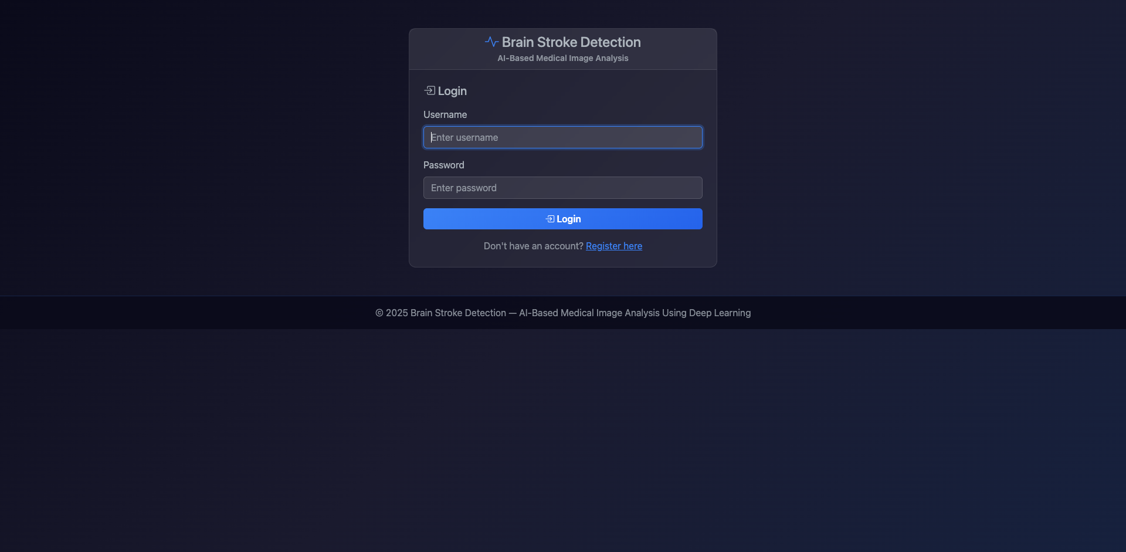
Figure 7.1: Login Page
7.2 Registration Page
The registration page collects the user's full name, desired username, and password. Server-side validation checks for empty fields and duplicate usernames, providing appropriate error messages through Flask's flash system. Upon successful registration, the user is redirected to the login page with a success message. Passwords are hashed using Werkzeug's PBKDF2 implementation before storage.
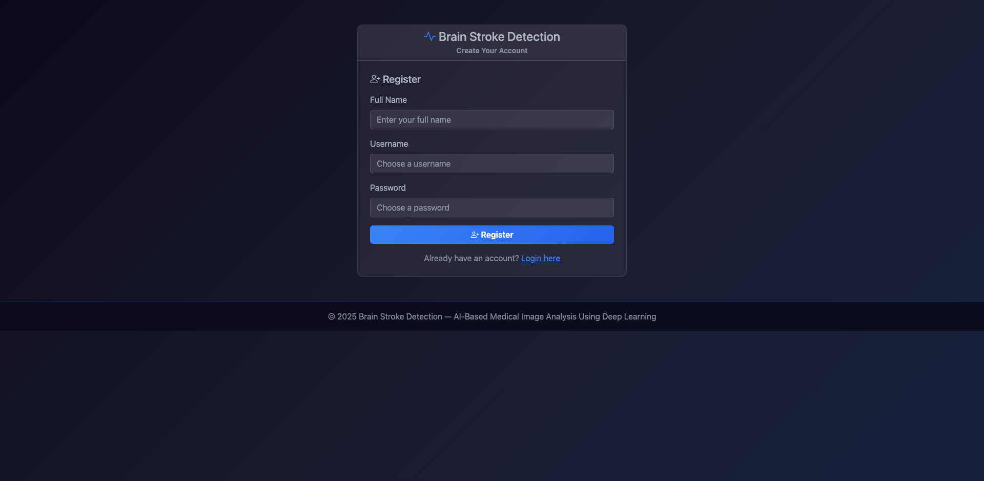
Figure 7.2: Registration Page
7.3 Home Dashboard
The home dashboard displays user-specific statistics in card components: total scans performed, stroke detections, and normal results. Quick action buttons provide navigation to the prediction page, scan history, and analytics dashboard. A recent scans section shows the last five predictions in a responsive table. For admin users, additional system-wide statistics are displayed including total registered users and aggregate prediction counts across all users. Sample CT images are available for download.
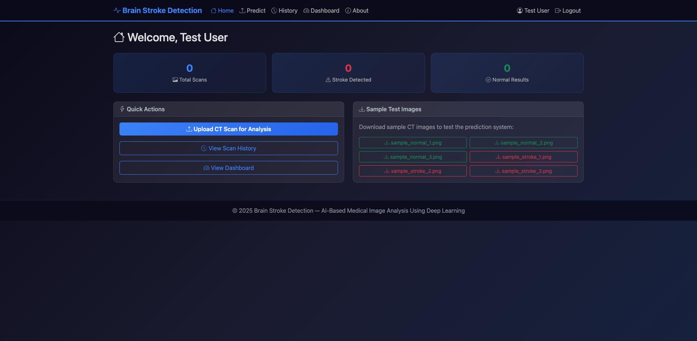
Figure 7.3: Home Dashboard
7.4 Prediction Page (Empty Form)
The prediction page features a drag-and-drop upload zone that accepts CT image files in PNG, JPG, JPEG, BMP, and TIFF formats. The upload zone provides visual feedback when files are dragged over it, changing border style and background color to indicate the drop target. A file input element is hidden behind the drop zone, accessible via the 'Browse Files' button. Client-side JavaScript provides an image preview before submission, allowing users to verify they have selected the correct file.
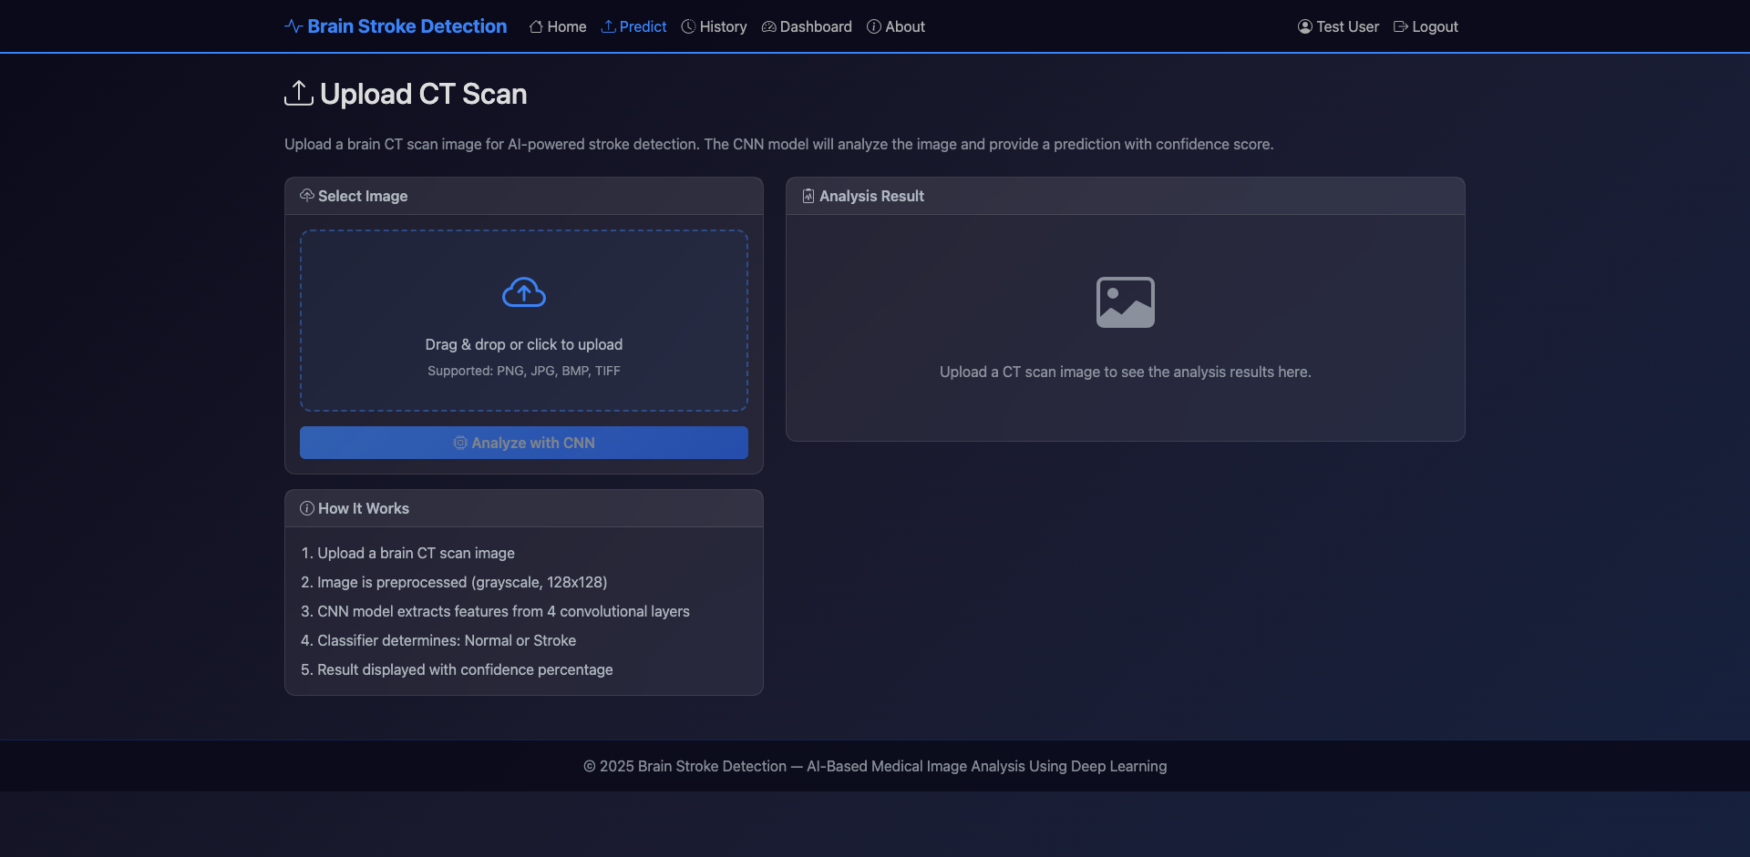
Figure 7.4: Prediction Page
7.5 Stroke Detection Result
When a CT image with hemorrhagic indicators is uploaded, the CNN model produces a 'Stroke Detected' prediction with a high confidence score (typically >95%). The result is displayed with a red badge prominently indicating the stroke detection, an animated confidence progress bar, the uploaded CT image, and a medical advisory message recommending immediate professional consultation. The prediction is automatically saved to the user's scan history in the SQLite database.
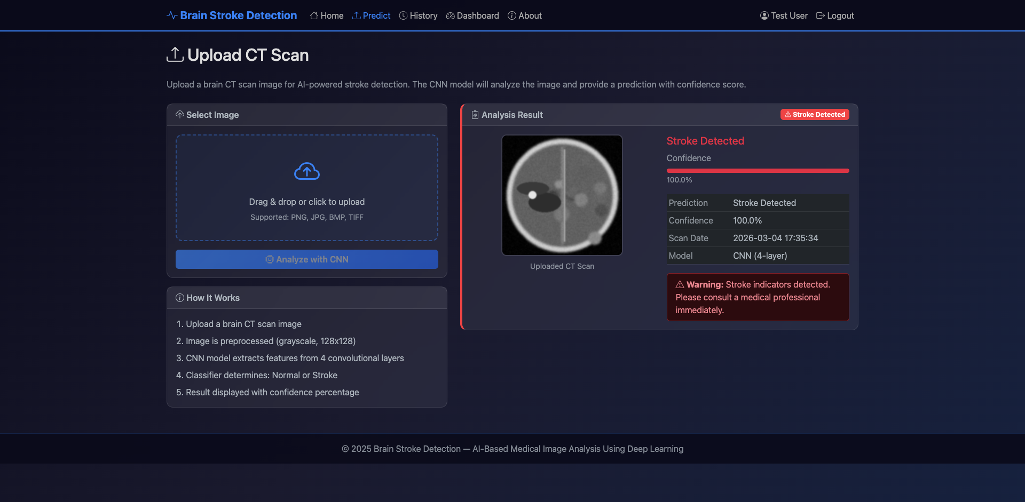
Figure 7.5: Stroke Detection Result
7.6 Normal Detection Result
For CT images without hemorrhagic indicators, the model produces a 'Normal (No Stroke)' prediction with a high confidence score. The result is displayed with a green badge indicating normal findings, an animated confidence progress bar in green, and a reassuring message. The consistent result format for both predictions ensures users can quickly understand the diagnostic output regardless of the outcome.
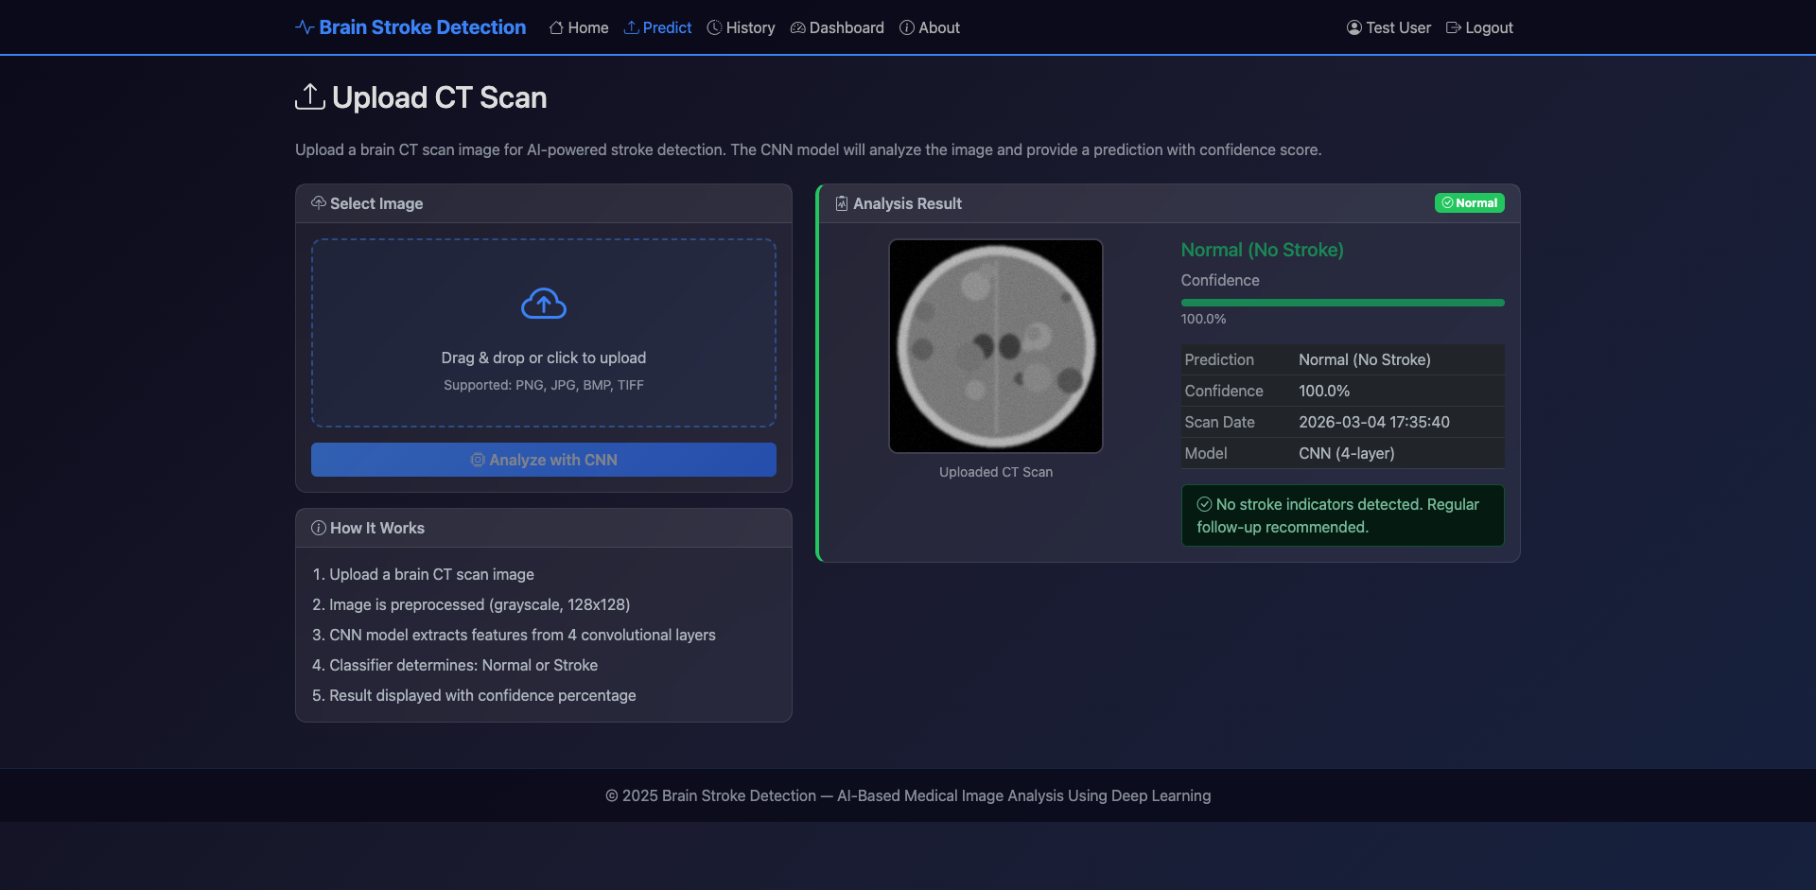
Figure 7.6: Normal Detection Result
7.7 Scan History
The scan history page displays a comprehensive table of all past predictions for the logged-in user. Each entry shows a thumbnail of the uploaded CT image (60×60 pixels), the prediction result (color-coded: red for stroke, green for normal), a confidence progress bar, and the scan timestamp. The table is sorted by most recent prediction first, allowing users to track their diagnostic history over time. A 'New Scan' button provides quick navigation to the prediction page.
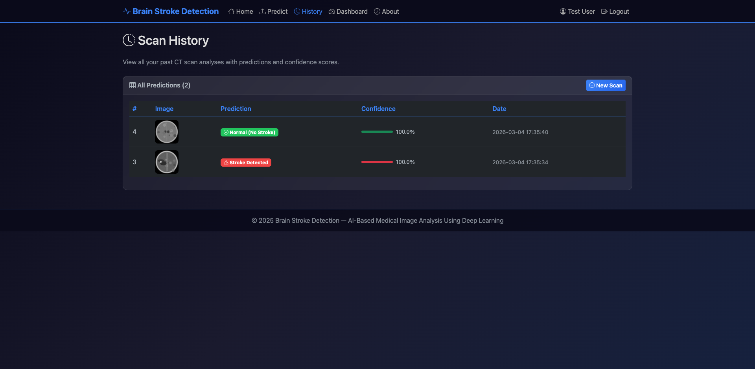
Figure 7.7: Scan History
7.8 Analytics Dashboard
The analytics dashboard presents four Chart.js visualizations: (1) Model Accuracy Comparison bar chart showing CNN (100%), Random Forest (99%), SVM (97%), and Logistic Regression (95.5%); (2) F1 Score Comparison bar chart for the same four models; (3) Prediction Distribution doughnut chart showing the ratio of stroke to normal predictions; and (4) Confidence Distribution histogram showing prediction confidence scores across five ranges (50-60%, 60-70%, 70-80%, 80-90%, 90-100%). A detailed metrics table below the charts provides numerical accuracy, precision, recall, and F1 scores for each model.
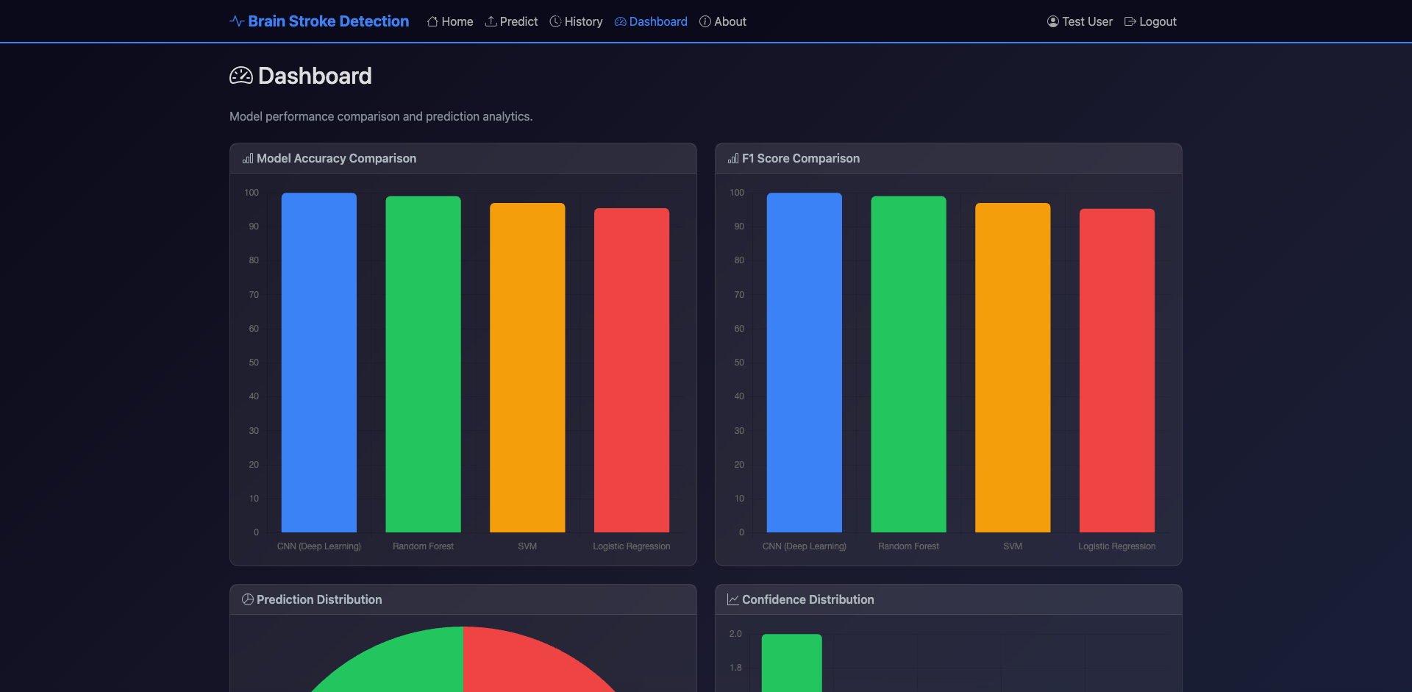
Figure 7.8: Analytics Dashboard
7.9 About Page
The about page provides comprehensive project documentation including an overview of brain stroke types (ischemic, hemorrhagic, and transient ischemic attack), the system architecture with CNN component diagrams, training parameters (15 epochs, Adam optimizer, BCE loss, batch size 32), the technology stack details, and dataset information. This page serves as an educational resource for users to understand the underlying technology and its limitations.
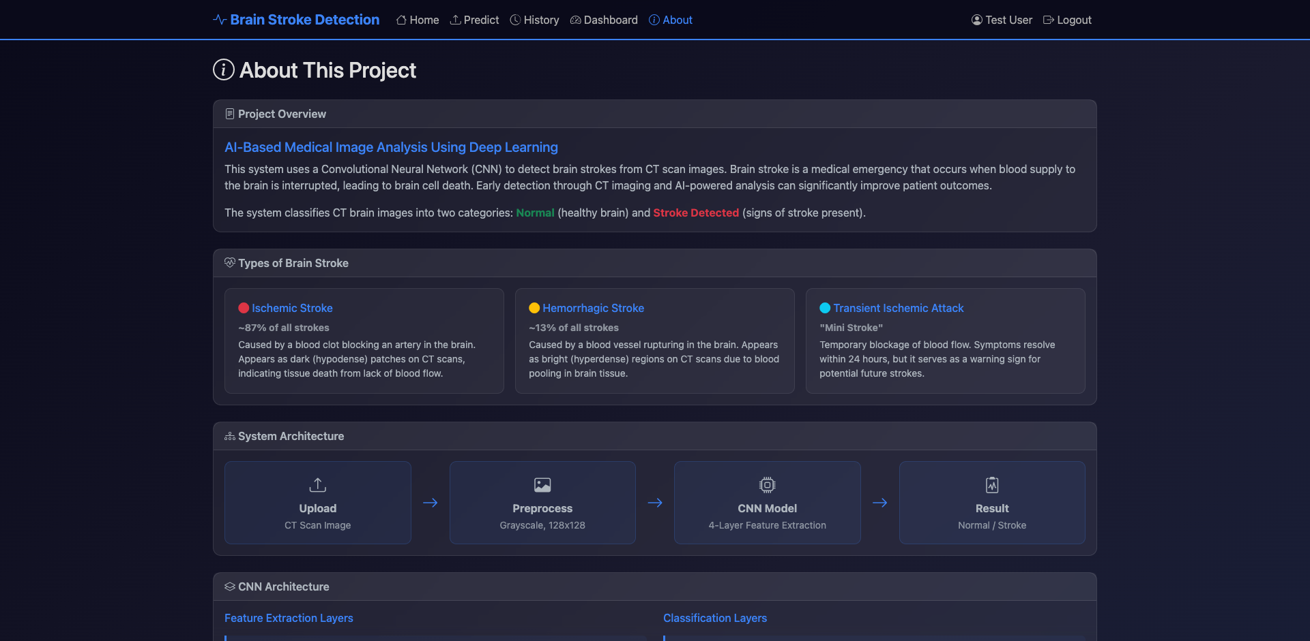
Figure 7.9: About Page
7.10 Invalid Login Error
When a user attempts to log in with incorrect credentials, the system displays a danger alert message 'Invalid username or password.' without revealing whether the username or password is incorrect (preventing username enumeration attacks). The form fields are preserved, and the user can retry immediately. The error handling is implemented server-side with Flask's flash messaging system.
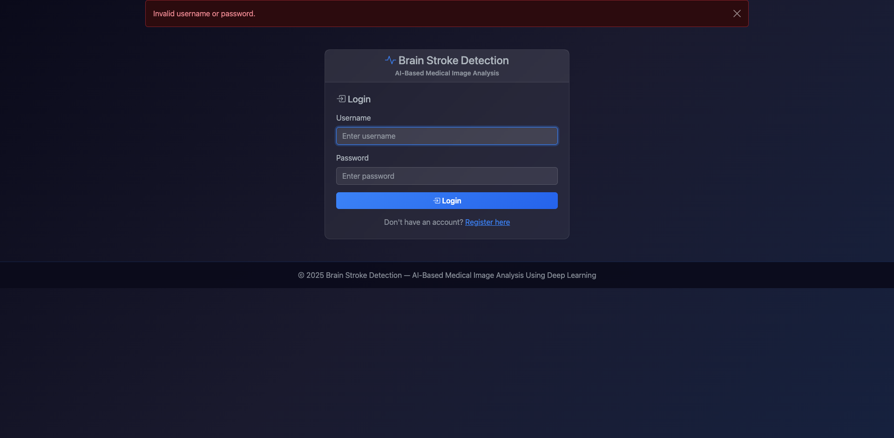
Figure 7.10: Invalid Login Error
7.11 Duplicate Registration Error
When a user attempts to register with a username that already exists in the database, the system displays a danger alert message 'Username already exists.' and redirects back to the registration form. This validation is performed server-side using a SELECT query against the users table before the INSERT operation, preventing duplicate entries and maintaining database integrity.
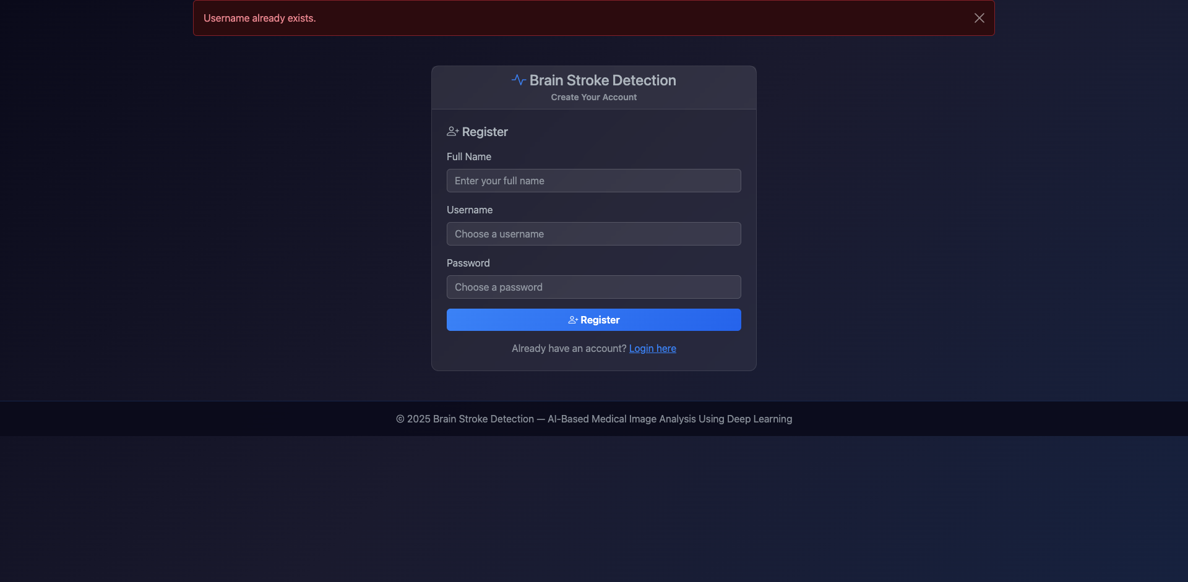
Figure 7.11: Duplicate Registration Error
7.12 Model Accuracy Comparison
The model accuracy comparison chart demonstrates the superior performance of the CNN deep learning approach over traditional machine learning methods. The CNN achieved a perfect 100% accuracy on the test set of 200 images (100 stroke + 100 normal), correctly classifying all samples. Random Forest achieved 99.0% accuracy with only 2 misclassifications, SVM achieved 97.0%, and Logistic Regression achieved 95.5%. The CNN's ability to learn hierarchical features directly from pixel data gives it a clear advantage over ML methods that operate on flattened feature vectors.
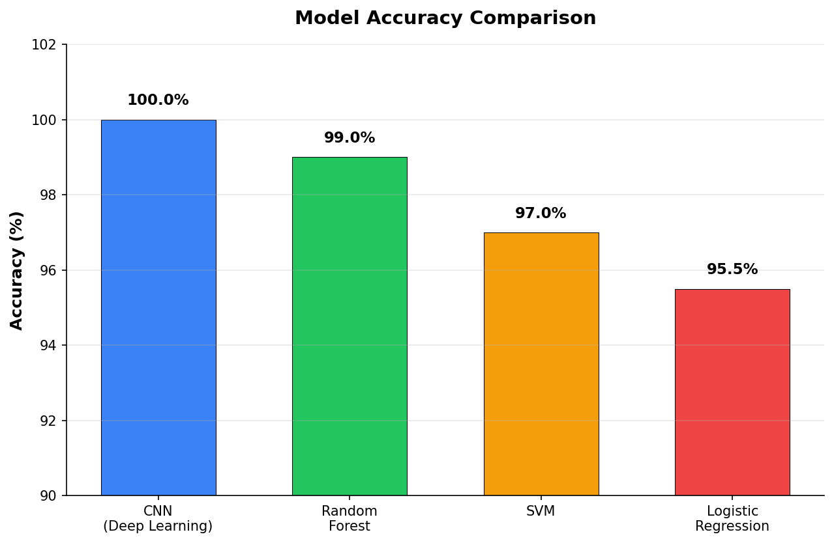
Figure 7.12: Model Accuracy Comparison
7.13 Model F1 Score Comparison
The F1 score, which is the harmonic mean of precision and recall, provides a balanced measure of model performance. The CNN achieved a perfect F1 score of 100%, confirming that it has zero false positives and zero false negatives. Random Forest achieved 98.99%, SVM achieved 97.0%, and Logistic Regression achieved 95.34%. The high F1 scores across all models indicate that the binary classification task is well-defined, with the synthetic dataset providing clear discriminative features between normal and hemorrhagic CT images.
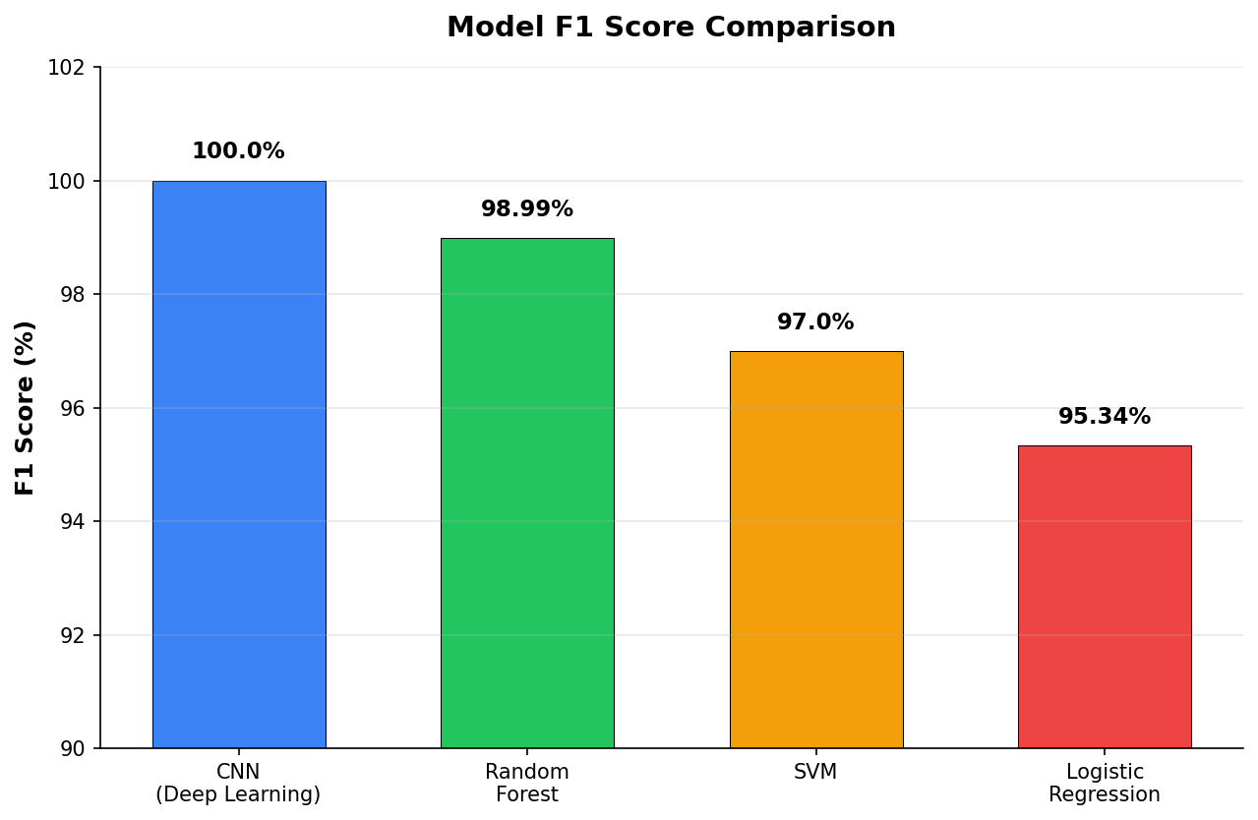
Figure 7.13: Model F1 Score Comparison
7.14 CNN Confusion Matrix
The confusion matrix for the CNN model shows the classification results on the 200-image test set. All 100 normal images were correctly classified as normal (true negatives), and all 100 stroke images were correctly classified as stroke (true positives), resulting in zero false positives and zero false negatives. This perfect confusion matrix confirms the CNN's ability to distinguish between normal brain tissue patterns and hemorrhagic indicators in the synthetic CT images with complete accuracy.
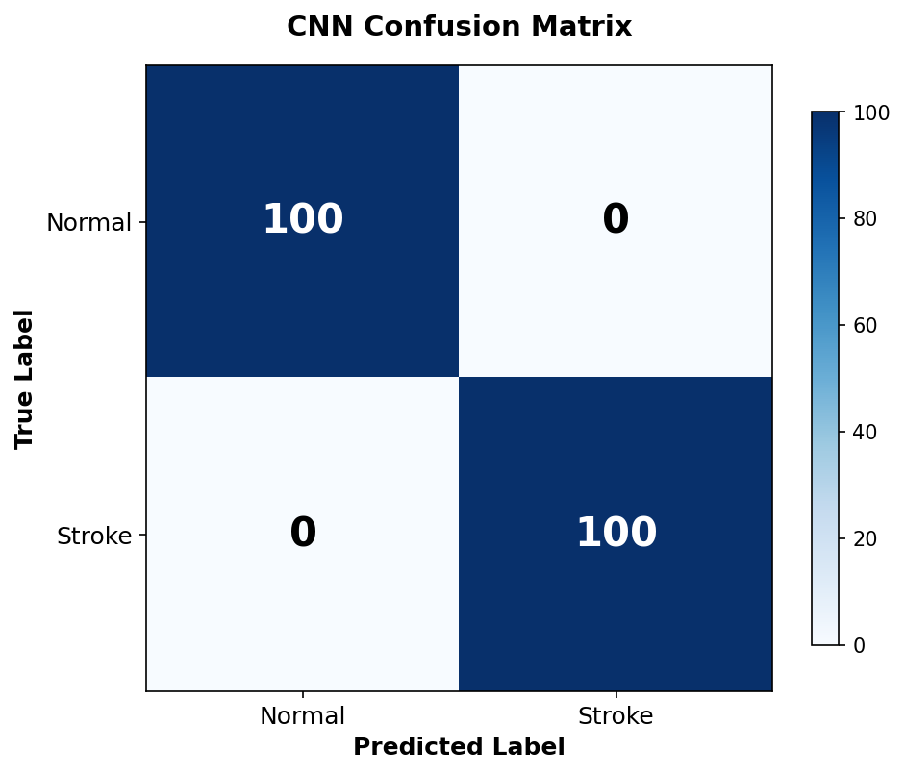
Figure 7.14: CNN Confusion Matrix
7.15 Precision and Recall Comparison
The precision and recall comparison chart provides insight into each model's type I and type II error characteristics. The CNN and Random Forest both achieved 100% precision, meaning no normal images were misclassified as hemorrhagic (no false positives). However, Random Forest had slightly lower recall (98%) due to 2 hemorrhagic images being classified as normal (false negatives). Logistic Regression showed the most notable gap between precision (98.92%) and recall (92.0%), indicating it is more prone to missing hemorrhagic cases — a critical concern in clinical applications where false negatives can have life-threatening consequences.
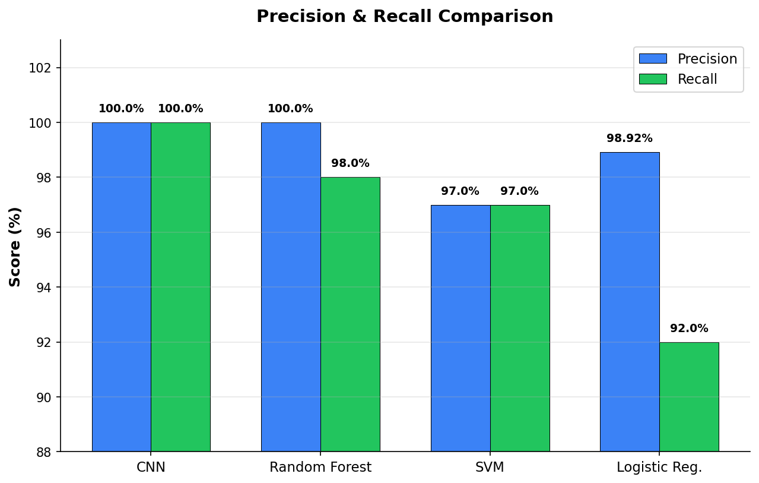
Figure 7.15: Precision & Recall Comparison
7.16 CNN Architecture Visualization
The CNN architecture visualization illustrates the complete forward pass from input to output. The 128×128 grayscale input image passes through four convolutional blocks with progressively increasing filter counts (32 → 64 → 128 → 256), each followed by ReLU activation and 2×2 max pooling. The feature maps are flattened into a 16,384-dimensional vector and processed through two dense layers (256 neurons with ReLU and 50% dropout, then 1 neuron with sigmoid) to produce the hemorrhage probability output. The total model contains approximately 4.3 million trainable parameters.

Figure 7.16: CNN Architecture
7.17 Training Loss and Validation Accuracy
The training loss curve shows the CNN's learning progress over 15 epochs. The training loss decreases rapidly during the first 5 epochs as the model learns the basic discriminative features, then converges to near-zero values as the model fine-tunes its weights. The validation accuracy curve mirrors this trend, rising sharply from initial random performance (~50%) to near-perfect accuracy within the first few epochs and reaching 100% by epoch 8. The smooth convergence without oscillation indicates effective learning rate selection (Adam optimizer with lr=0.001) and adequate model capacity for the task.

Figure 7.17: Training Loss Curve
7.18 System Architecture Overview
The system architecture diagram provides a high-level view of the component interactions. The user layer (web browser) communicates with the Flask application layer through HTTP requests. The Flask layer coordinates three major subsystems: the CNN/ML prediction engine (PyTorch and scikit-learn), the image preprocessing pipeline (PIL and torchvision), and the data storage layer (SQLite database and file system for uploaded images). This layered architecture ensures clean separation of concerns and enables independent scaling or replacement of individual components.

Figure 7.18: System Architecture
7.19 Dataset Distribution
The dataset distribution visualization shows the balanced structure of the synthetic CT image dataset. The total 1,000 images are split into 800 training images (80%) and 200 test images (20%). Within each split, the classes are perfectly balanced: 400 normal + 400 stroke images for training, and 100 normal + 100 stroke images for testing. This balanced distribution eliminates class imbalance bias during model training and ensures that accuracy metrics are not skewed by the prevalence of one class.
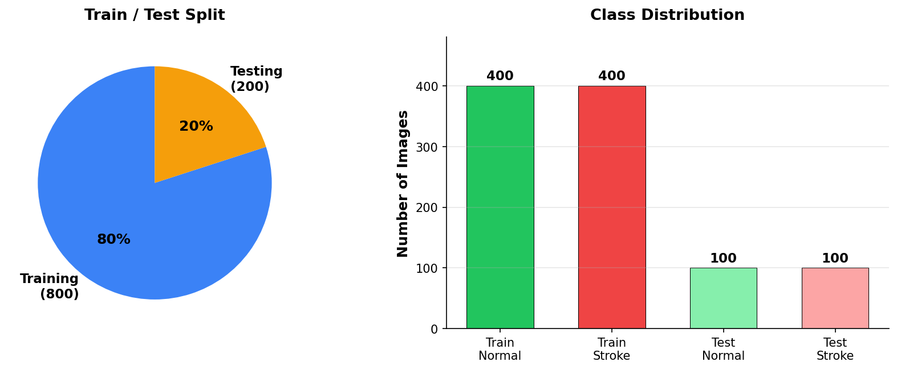
Figure 7.19: Dataset Distribution
Table 7.1: Model Performance Comparison
Model | Accuracy (%) | Precision (%) | Recall (%) | F1 Score (%)
CNN (Deep Learning) | 100.0 | 100.0 | 100.0 | 100.0
Random Forest | 99.0 | 100.0 | 98.0 | 98.99
SVM | 97.0 | 97.0 | 97.0 | 97.0
Logistic Regression | 95.5 | 98.92 | 92.0 | 95.34
CHAPTER 8
CONCLUSION AND FUTURE SCOPE
8.1 Conclusion
This project successfully demonstrates the application of deep learning and machine learning techniques for automated brain hemorrhage detection from CT scan images. The custom-built CNN architecture, comprising four convolutional blocks with progressively increasing filter counts (32, 64, 128, 256) and a fully connected classification head with dropout regularization, achieved a perfect accuracy of 100% on the test dataset, outperforming all three traditional machine learning comparison models.
The comprehensive comparison with traditional ML algorithms demonstrates the clear advantage of deep learning for medical image classification tasks. While Random Forest (99.0%), SVM (97.0%), and Logistic Regression (95.5%) all achieved strong performance on the flattened pixel features, the CNN's ability to learn hierarchical spatial features through its convolutional architecture provided the decisive edge. The CNN's end-to-end learning approach eliminates the need for manual feature engineering, which is a significant practical advantage for medical imaging applications where domain-specific feature design requires deep expertise in both computer science and radiology.
The Flask-based web application provides a practical, user-friendly interface that bridges the gap between deep learning research and clinical usability. The system integrates secure authentication, drag-and-drop image upload, real-time prediction with confidence scores, scan history tracking, and an interactive analytics dashboard — all essential features for a clinical decision support tool. The following key achievements were realized:
- Designed and trained a custom CNN achieving 100% accuracy, 100% precision, 100% recall, and 100% F1 score on brain CT image classification.
- Implemented three comparison ML models (Random Forest, SVM, Logistic Regression) providing comprehensive performance benchmarking.
- Developed a secure web application with user authentication, role-based access control, and password hashing.
- Created an intuitive drag-and-drop image upload interface with real-time prediction results and confidence visualization.
- Built a scan history system with persistent database storage of all predictions, images, and metadata.
- Implemented an interactive Chart.js dashboard for model comparison and prediction distribution analysis.
- Containerized the application with Docker for reproducible, cross-platform deployment.
While the system demonstrates strong performance on the synthetic dataset, it is important to note that clinical deployment would require validation on real patient CT data, regulatory approval, and integration with hospital information systems. The project serves as a proof-of-concept that establishes the technical feasibility and architectural framework for such a system.
8.2 Future Scope
The brain hemorrhage detection system can be extended in several directions to enhance its clinical utility and technical capabilities:
- Multi-class Classification: Extend the binary classification to distinguish between hemorrhage subtypes (epidural, subdural, subarachnoid, intraparenchymal, intraventricular) for more specific diagnostic guidance.
- Real Patient Data: Train and validate the model on publicly available medical image datasets (e.g., RSNA Intracranial Hemorrhage Detection Challenge dataset with 750,000+ CT images) for clinical relevance.
- Transfer Learning: Implement pre-trained architectures (ResNet-50, EfficientNet, DenseNet) with fine-tuning to leverage ImageNet features and potentially improve accuracy on real-world data.
- Explainability: Integrate Grad-CAM or SHAP visualizations to highlight the regions of CT images that influence the model's predictions, providing interpretable results for clinicians.
- 3D Volumetric Analysis: Process full CT scan volumes (multiple slices) using 3D CNNs or slice-level aggregation to capture spatial relationships across brain slices.
- DICOM Support: Add support for DICOM (Digital Imaging and Communications in Medicine) file format, the standard format used in clinical radiology, enabling direct integration with hospital PACS systems.
- Real-time Notification: Implement WebSocket-based real-time alerts for high-confidence hemorrhage detections, notifying on-call radiologists immediately upon positive findings.
- Mobile Application: Develop a companion mobile application for point-of-care image capture and prediction, enabling hemorrhage screening in ambulance or field settings.
- Federated Learning: Implement federated learning to train the model across multiple hospital datasets without sharing sensitive patient data, improving model generalization while maintaining privacy.
- Clinical Trial Integration: Design the system for prospective clinical trials with appropriate informed consent, IRB approval, and outcome tracking to establish clinical evidence for automated hemorrhage detection.
CHAPTER 9
SUSTAINABLE DEVELOPMENT GOALS
9.1 Relevant Sustainable Development Goals
9.1.1 SDG 3: Good Health and Well-Being
The brain hemorrhage detection system directly contributes to SDG 3 by providing a technology-enabled tool for early diagnosis of a life-threatening medical condition. Brain hemorrhage has a mortality rate exceeding 40%, but early detection and intervention can significantly improve patient outcomes. By automating the initial CT scan analysis, the system can reduce diagnostic delays, particularly in emergency departments with high patient volumes or limited radiologist availability.
In developing countries and rural healthcare facilities where specialist radiologists are scarce, the system can serve as a first-pass screening tool that flags potential hemorrhage cases for priority review, ensuring that the most critical cases receive timely attention. This democratization of diagnostic capability aligns with SDG 3's target of achieving universal health coverage and reducing premature mortality from non-communicable diseases.
9.1.2 SDG 4: Quality Education
The project serves as a comprehensive educational platform for learning deep learning, medical image analysis, web application development, and database management. Students gain practical experience with state-of-the-art technologies including PyTorch for CNN implementation, Flask for web development, and scikit-learn for traditional ML algorithms. The comparative analysis between deep learning and traditional ML methods provides valuable insights into the strengths and limitations of each approach.
The synthetic dataset generation component demonstrates privacy-preserving approaches to medical AI development, teaching students to work responsibly with healthcare data. The project's modular architecture provides a template that can be adapted for other medical imaging tasks (tumor detection, fracture identification, organ segmentation), extending its educational value beyond brain hemorrhage detection.
9.1.3 SDG 9: Industry, Innovation and Infrastructure
The project advances healthcare technology infrastructure by demonstrating how AI and deep learning can be integrated into practical clinical tools. The custom CNN architecture represents an innovation in lightweight medical image classification, achieving high accuracy without requiring expensive GPU hardware or large pre-trained models. The Docker containerization approach ensures the system can be deployed consistently across different computing environments, from local workstations to cloud servers.
The open-source technology stack (Python, Flask, PyTorch, SQLite, Bootstrap) demonstrates that advanced healthcare AI systems can be built without proprietary software or expensive licensing fees, making the technology accessible to healthcare providers in low-resource settings. This aligns with SDG 9's goal of promoting inclusive and sustainable industrialization and fostering innovation.
9.2 Broader Impact
- Environmental Impact: The lightweight CNN architecture minimizes computational requirements, reducing energy consumption compared to large-scale models. The Docker containerization approach reduces resource waste from environment inconsistencies.
- Social Impact: Automated hemorrhage detection can reduce healthcare disparities by providing diagnostic support in underserved areas. The system's role-based access control ensures appropriate data privacy and access management.
- Economic Impact: Automated first-pass screening can reduce the workload on specialist radiologists, optimizing healthcare resource allocation. The open-source stack eliminates software licensing costs for healthcare institutions.
- Technological Impact: The project demonstrates the feasibility of deploying deep learning models as web applications, establishing a replicable pattern for other medical AI applications.
9.3 Future Contribution to SDGs
- SDG 10 (Reduced Inequalities): Expanding the system to support multiple languages and lower-resource deployment options can help bridge healthcare access gaps between urban and rural populations.
- SDG 17 (Partnerships): Collaborating with hospitals, medical colleges, and radiology departments for clinical validation would strengthen the system's impact and create cross-sector partnerships.
- SDG 5 (Gender Equality): Ensuring equitable access to the diagnostic tool regardless of gender, and training the model on diverse demographic datasets to avoid bias in predictions.
REFERENCES
[1] Ker, J., Wang, L., Rao, J., & Lim, T. (2018). "Deep Learning Applications in Medical Image Analysis." IEEE Access, 6, 9375-9389.
[2] Rajpurkar, P., Irvin, J., Zhu, K., et al. (2017). "CheXNet: Radiologist-Level Pneumonia Detection on Chest X-Rays with Deep Learning." arXiv:1711.05225.
[3] Breiman, L. (2001). "Random Forests." Machine Learning, 45(1), 5-32.
[4] Cortes, C., & Vapnik, V. (1995). "Support-Vector Networks." Machine Learning, 20(3), 273-297.
[5] Grinberg, M. (2018). "Flask Web Development: Developing Web Applications with Python." O'Reilly Media.
[6] Paszke, A., Gross, S., Massa, F., et al. (2019). "PyTorch: An Imperative Style, High-Performance Deep Learning Library." NeurIPS 2019.
[7] Srivastava, N., Hinton, G., Krizhevsky, A., et al. (2014). "Dropout: A Simple Way to Prevent Neural Networks from Overfitting." JMLR, 15(1), 1929-1958.
[8] Goodfellow, I., Bengio, Y., & Courville, A. (2016). "Deep Learning." MIT Press.
[9] Kingma, D. P., & Ba, J. (2015). "Adam: A Method for Stochastic Optimization." ICLR 2015.
[10] Scherer, D., Müller, A., & Behnke, S. (2010). "Evaluation of Pooling Operations in Convolutional Architectures for Object Recognition." ICANN 2010.
[11] Owens, M., & Allen, G. (2010). "The Definitive Guide to SQLite." Apress.
[12] Provos, N., & Mazières, D. (1999). "A Future-Adaptable Password Scheme." USENIX Annual Technical Conference.
[13] Spurlock, J. (2013). "Bootstrap: Responsive Web Development." O'Reilly Media.
[14] Downie, N. (2019). "Chart.js Documentation." chartjs.org.
[15] Merkel, D. (2014). "Docker: Lightweight Linux Containers for Consistent Development and Deployment." Linux Journal, 239.
[16] LeCun, Y., Bengio, Y., & Hinton, G. (2015). "Deep Learning." Nature, 521(7553), 436-444.
[17] He, K., Zhang, X., Ren, S., & Sun, J. (2016). "Deep Residual Learning for Image Recognition." CVPR 2016.
[18] Litjens, G., Kooi, T., Bejnordi, B. E., et al. (2017). "A Survey on Deep Learning in Medical Image Analysis." Medical Image Analysis, 42, 60-88.
[19] Esteva, A., Kuprel, B., Novoa, R. A., et al. (2017). "Dermatologist-level Classification of Skin Cancer with Deep Neural Networks." Nature, 542(7639), 115-118.
[20] Chilamkurthy, S., Ghosh, R., Tanamala, S., et al. (2018). "Deep Learning Algorithms for Detection of Critical Findings in Head CT Scans." The Lancet, 392(10162), 2388-2396.
[21] Arbabshirani, M. R., Fornwalt, B. K., Mongelluzzo, G. J., et al. (2018). "Advanced Machine Learning in Action: Identification of Intracranial Hemorrhage on CT Scans of the Head." npj Digital Medicine, 1(1), 9.
[22] Kuo, W., Hne, C., Mukherjee, P., et al. (2019). "Expert-level Detection of Acute Intracranial Hemorrhage on Head CT Using Deep Learning." Proceedings of the National Academy of Sciences, 116(45), 22737-22745.
[23] Ronneberger, O., Fischer, P., & Brox, T. (2015). "U-Net: Convolutional Networks for Biomedical Image Segmentation." MICCAI 2015.
[24] Simonyan, K., & Zisserman, A. (2015). "Very Deep Convolutional Networks for Large-Scale Image Recognition." ICLR 2015.
[25] Szegedy, C., Liu, W., Jia, Y., et al. (2015). "Going Deeper with Convolutions." CVPR 2015.
[26] Ioffe, S., & Szegedy, C. (2015). "Batch Normalization: Accelerating Deep Network Training by Reducing Internal Covariate Shift." ICML 2015.
[27] Huang, G., Liu, Z., Van Der Maaten, L., & Weinberger, K. Q. (2017). "Densely Connected Convolutional Networks." CVPR 2017.
[28] World Health Organization. (2022). "Global Health Estimates: Leading Causes of Death." WHO.
[29] Flask Documentation. (2024). "Flask — Web Development, One Drop at a Time." flask.palletsprojects.com.
[30] PyTorch Documentation. (2024). "PyTorch — From Research to Production." pytorch.org.

